# Chapter 3: Analysing Digital Methods – A Return to Hermeneutics

At the beginning of our century, the French Historian François Hartog published a seminal work to reflect on the conditions of producing history in the current time in his *Regimes d’Historicité* (2003), Hartog points out a profound alteration in the way contemporary society perceives the passage of time. Since Hartog's publication, several studies have claimed that the electronic culture, increasingly ubiquitous, is accountable for the potentisation of the accelerated experience of time that characterises today's presentism. To Hartog, acceleration is only one of the symptoms of this specific regime of historicity, the increasing attention to historical heritage and related public policies, as well the growing fascination towards the past in the mainstream media are equally meaningful markers of this temporal experience. The transition from the print to the digital age seems to be the momentous shift in which Hartog’s reflections are circumscribed. As early as 2004, Italian historian Dario Ragazzini wrote:

It follows that daily activity - high or low, exceptional or ordinary - leaves information traces, which will be the documents and sources of the future history of our present. As the historiography of an alphabetical culture is different from that of an oral culture, so the historiography of a digital culture will – and already is – different from that of a literal culture. (Ragazzini 2004, vii, translated from Italian by myself)[1]

As Ragazzini argues, the culture of our time is different and so will be the historical craft. Digital technology – as it has been greatly demonstrated in the advancing realms of digital and public history – enables a vast range of possibilities to interrogate and (re)present the past to our peers and publics. While up to now, new forms of delivering historical knowledge in digital formats have been prominent in digital history and public history research, so far there have been few empirical investigations into the methodological and interpretative dimensions of historical research in the digital age. **In this chapter, I discuss, based on insights from the Memorecord case study, how the *digital component*** (Berry 2011, 12) **is conditioning historical research in its full capacity.**

While the previous chapter had a stronger descriptive emphasis for introducing the Memorecord case study, the present discussion will adopt an analytical pitch, interspersed with some practical suggestions on how we could embrace the challenges of the new conditions of producing historical research in the digital age. To address these challenges, I will reflect upon them as part of this new **conditioning** inflicted by the digital component and will offer an assessment of what I am designating **digital interferences**, a series of ontological implications brought by the digital novelties that create interferences on methods and interpretation of history. The intricate relation between the different phases of the historiographical operation – documental, explication, representation – as proposed by Michel de Certeau (1988), may have become commonplace. However, for the discussion proposed in this chapter, the nexus among these different phases is far from trivial. To understand the proportion to which the **digital interferences** can create disturbances, enabling and disabling heuristic tools for historiography, we need to think about the said operation as a whole system, in which the different phases are all interconnected and bound by interdependencies.

Bearing in mind the internal interdependencies of the historiographical operation, however, is not enough to merely understand how the digital component can shape the historical profession. It is necessary to anchor the micro system of a particular operation into the macro societal cultural environment in which the involved subjects of the given research live. So, even referring to an isolated case study like the one of Memorecord, knowing that it provides a rather specific intel on its context and experience, in this chapter I will purposefully keep a dialogue with broader debates – such as the one on temporality tackled by Hartog, or the transition to the digital culture indicated by Ragazzini – that are fundamental to understand the embeddedness of this case study in this specific time and culture pervaded by the digital component.

To offer a deep reflection on methods and interpretation we need both the clear-cut focus of said approach and the bigger picture in which this could be developed – the historian’s individual resources and positioning, institutional background, available infrastructure & expertise, and, finally, the *glocal* context of it (Noiret and Cauvin 2017, 26)[2]. Beyond highlighting the innovation proposed by an experiment with the digital and presenting the outcomes of a project, as I just discussed in the previous chapter, it is fundamental to look at the process on its own, often a non-linear progress, considering its successes and failures. The very epistemological notions of historical discipline might be at stake, and we will only be able to look at it within historicity if we pay attention to innovations, of course, but also to the established tradition’s readiness to welcome the new practices and ways of thinking. The friction between old and new organising principles of scientific historical thinking before and after the digital turn, as I will argue, is at the core of digital scholarship (lack of) acceptance.

In this manner, the analysis proposed in this chapter should help to bring forward the dialectical tacking between *tradition* and *innovation* in digital history’s historiography, which I discuss under the notion of **hybridisation**. As the process of hybridisation unfolds, I propose to reflect on digital history and digital public history approaches, beyond the hype and reiterating debates about new challenges and definitions of computational techniques, but as systems that include new forms of narratives, methods and interpretation that are subjected to **digital interferences**.

Both digital history and digital public history, I argue, need strong footholds within the vast tradition of critical reflection and understanding, for which, I suggest a return to hermeneutics and more specifically digital hermeneutics as **hermeneutics of practice -** a theory of practices that allows us to critically reflect on the theoretical and artisanal challenges of our digital work and devise practical solutions to face them. In the following sections, I will constantly *zoom in* and *out* from the empirical exercise of building Memorecord, in an attempt to bridge the points of reflection offered by my hands-on experiment with the far-reaching discussion on digital public history, historiography and what we do as historians today.

# The experimental *ethos*

To build an understanding of digital hermeneutics as *a hermeneutics of practice* in the digital history realm, we need to consider the experimental *ethos* that pervades Digital Humanities as a whole and sprinkles across digital history too. Typically central to the hard sciences, the eagerness for experimentation seems to have also been spread amidst digital practitioners across different disciplines in the humanities and social science domains. The emergence of an experimental approach trend may be related, in its core, to the newness of the digital and the uncertainties it brings. The need to find out what is possible, how to do it, the perks and flaws of a precise tool or environment, all lead to the need for testing and trying things out, using different solutions, just as I did in Memorecord's crowdsourcing, as discussed in Chapter 1. The unknown, hence, seems to call for a return to trial and error which gradually introduce a *laboratory ethos* (Lane 2016, 2) to those in the humanities that join the digital adventure.

While it is true that a *learning by doing* or “doing as thinking” (Drucker 2012, 87) mode became somewhat necessary in the making and training of the (new) digital practitioners, before moving reflection on the economy of hands-on work with the digital, we should not lose sight that the use of terms like laboratory and data, or other borrowings from the sciences that concurs for a “scientification of humanities”, as argued by Urszula Pawlicka-Deger (Pawlicka 2017, 527), is inscribed in a broader context of "crisis of the humanities" in which a "practice turn" was proposed as a response to the contingencies in the broader field of humanities and social sciences (527-528).

In 2010, Martha C. Nussbaum had already signalled a silent crisis in the humanities. In her book *Not for Profit – Democracy needs the Humanities*, speaking mostly about the American context, Nussbaum identifies the core of the problem being the shift from an education for a civic and empathetic formation to a model which is rather economically driven and expects students to be productive instead of becoming competent democratic citizens. For the philosopher, this situation could have an impact of enormous proportions at a global level, endangering the very future of democracy (Nussbaum 2010, 19–20). Other authors see the recent attacks to the humanities rather as a crisis of the sense of the humanities in itself, in need for rediscussing and redefining its object (García 2017). Without drifting too deeply into the history and philosophy of science, one could follow Rosi Braidotti in her arguments that the neoliberal social climate is accountable for the overall downgrade of Humanistic studies (Braidotti 2013, 11).

To offer further consideration on this crisis might be a rather long digression for this introductory section, however, it is important to bear in mind a few nuances in the crisis debate. I understand the dynamics of this crisis to be intrinsically related to the ideology of *do it* (Peran 2016)and the *SmartPolitics* of neoliberalism in its digital age expression (Han 2017, 36). There is a broader discussion with big words on “Capitalism of…”, “Society of…”, “Polítics of…” to describe the world in which we now live as discussed in Chapter 1, but for now it is necessary to simply signal that the ethics debates I engage with in this thesis are rooted in the critique of the *capitalism of transparency*, the habits, rhetorics and modes of control it engenders[3].

Having said that, let’s consider that there is some elasticity in the discussion about the possible causes of the crisis in the humanities, some with more apocalyptic perceptions than others. To avoid the risk of taking a Manichaean analysis of this situation for the humanities at large, there are at least two in-depth manifestos that dialogue with the recent struggles of higher education worldwide: *Manifesto for the Humanities: Transforming Doctoral Education in Good Enough Times* by Sidonie A. Smith (2015) and the *Arts and Humanities in Progress: A Manifesto of Numanities,* by Dario Martinelli (2016). Both address the neoliberal values influencing the research agenda and the commercialisation of research activities: Those texts are self-critical and try to avert the shortest way of “blaming the system” (Martinelli 2016, 01). Smith sets an optimistic mantra in the beginning of her manifesto, stating that " 'the times are good enough' to make significant changes in how future humanists are educated” (2015, 01) and refers to profound shifts in the ecology of higher education that:

relate to the evolving concept of university; the epistemic infrastructure, the new media and modes of scholarly production and communication; the trend toward the 'open'. the reorientation of learning environments; and the emergent profile of a possible posthuman humanities scholar (Smith 2015, 01–02)

Martinelli’s manifesto also displays a rather encouraging tone:

In fact, while 'crisis' is the term that many scholars refer to, when they analyse the current condition of the humanities, one should also keep in mind that the word should be taken not only in its negative connotation but in a more comprehensive, etymological sense (that is, Greek krisis, which rather means 'selection, judgement, turning point.). In other words, a crisis is a precondition for evolution (Martinelli 2016, 12)

From the point of view of a rather hybrid scholar, Blaine Greteman also indicates constructive points of reflexion on the opportunities of the crisis, ironically grounding the current "crisis" in a broader six-hundred-year history. In his stinging opinion text, *It's the* *End of the Humanities as We Know It. And I Feel Fine* he provokes: “Like a consumptive protagonist in a Victorian novel the humanities have been dying for a long, long time” (Greteman 2014). Greteman, himself a scholar who is witnessing the transition to digital that we are experiencing, also sees the need for adaptation to the new difficult times and claims it as a natural development of the humanities. He alludes to the historicity of dramatic discourses about the crisis of the humanities and recalls a text that appeared on *The New Republic in the* 1970's: " 'English,' wrote poet, professor, and editor Reed Whittemore, ‘is going down the drain.’” Gretemen continues:

In fact, the humanities have been going down that drain since at least 1621, when Robert Burton blamed their decline for the rampant disease of melancholia attacking scholars of his generation (...) Lately, the prime culprits in this deathbed scene are either out-of-touch traditionalists, who refuse to adapt to a changing world and “instruct students in contemporary media platforms,” or digital humanists chasing new trends and succumbing to “the language of salesmanship” instead of defending the tradition.

I am probably doubly culpable: I published a scholarly tome at the world’s oldest press, and I currently lead a team that is data mining over 487,000 book records and building a website reconstructing and visualising the social networks of Shakespeare, John Locke, Benjamin Franklin, and their peers. I really do wear tweed, but I also tweet at my pijama-wearing students when I’m not harping on them to turn off their damn phones and bring their books to class. Mea culpa. (Greteman 2014)

Greteman is an associate professor of English at the University of Iowa and head of digital projects like *Linked Reading: A New Scalable Model for the Digital Humanities*[4], that "involves elements of close, distant, and scalable reading, but it adds a new dimension: that of linked reading, or the creation of new interpretive possibilities by the joining of humanistic datasets" and *Shakeosphere – Mapping early modern social networks*[5], that "gathers metadata about authors, publishers, booksellers, and printers for nearly half a million texts printed from 1473 to 1800".

Not by chance, one of Greteman’s projects, Linked Reading, is part of the *Digital Bridges for Humanistic Inquiry*, a "multi-year experiment with a variety of collaborative practices in the humanities" funded by the Andrew W. Mellon Foundation (2015-2018)[6]. The *Digital Bridges* overview pages reads:

Through our experiments in collaboration, we seek not only to respond to the market’s demands for technical know-how and team-building, but also to sustain the best of the humanities—reflection, interpretation, historical context, culturally diverse explorations of multiple points of view, and the pursuit of understanding the world in all its diversity. (Digital Bridges, About us, Overview, emphasis added by myself)

This kind of response to the “market’s demands” – or to the crisis in the humanities – can eloquently illustrate Matthew Kirschenbaum Gold’s notion that “digital humanities as/is a tactical term” (Gold 2012, 415) without questioning the intellectual integrity of the various projects, laboratories and initiatives that continue arising with similar scopes and goals – movement in which I can also situate the funding and development of Memorecord, although, in this case leaning towards of digital history. Turning back to Braidotti’s view of the crisis mentioned above, Gold’s reflexion about the (digital) humanities, could be seen as a way out of the pressure of the neoliberal politics that connects the university to the marketplace:

To assert that digital humanities is a “tactical” coinage is not simply to indulge in neopragmatic relativism. Rather, it is to insist on the reality of circumstances in which it is unabashedly deployed to get things done – "things" that might include getting a faculty line or funding a staff position, establishing a curriculum, revamping a lab, or launching a centr. At a moment when the academy in general and the humanities, in particular, are the objects of massive and wrenching changes, digital humanities emerges as a rare vector for jujitsu, simultaneously serving to position the humanities at the very forefront of certain value-laden agendas – entrepreneurship, openness and public engagement, future-oriented thinking, collaboration, interdisciplinarity, big data, industry tie-ins, and distance or distributed education – while at the same time allowing for various forms of intrainstitutional mobility as new courses are approved, new colleagues are hired, new resources are allotted, and old resources are reallocated. (Gold 2012, 415–16)

The reference to the Japanese martial art jujitsu in this context is expressive. In a free translation from the Japanese *jūjutsu*, *Jū* means "softness", "mildness", "flexibility" and *jutsu*, "art", "technique". This specific kind of fight is known to use lever strike, twist and pressure techniques to take down and dominate an opponent. In action, opponents use the whole body as a combat tool and also intend to benefit from the opponent’s body too, using their energy and body, through projections, immobilisation and so on. Through this combat analogy, considering digital humanities tactical in the larger context of the crisis does not imply any cynicism with regard to the ethics of those in the field, it rather tells us about their craftiness to balance their efforts to adapt to the new times with the proper resistance and flexibility. To do so, on the one hand, scholars of various generations engage with the digital, rethinking approaches, curricula, producing new artefacts and accepting new objects/materials as *work matter* for humanistic studies. On the other hand, they might also need to adapt and comply with the exigency of the DH funders that expect impact, high interdisciplinarity, high levels of engagement and market-consciousness (Opel and Simeone 2019). To a greater extent, more funders have “performance-based expectations that are best addressed by an entrepreneurial approach” (Thorp and Goldstein 2010, 10). All of this pushes for a more technical and entrepreneurial discourse and Dawn Opel and Michael Simeone have noted, “[i]nevitably, the paradigm of funding shapes the kind of work that is done and the tools and methods that are used." (Opel and Simeone 2019).

What I want to highlight by bringing forward the above-mentioned aspects of the aforementioned crisis in the humanities is the non-neutrality of the responses to those pressures in research as a whole. There is, indeed, a real interest for new methods and tools that is increased by the digital, but we must keep in mind that the universities struggle for funding, especially in the humanities, and when coupled with the discoverability enthusiasm and, just as technology does, it enables and disables certain types of research. In this context, the commitment and/or opportunity to try something new may happen in different scales, with minor or larger interferences in the daily routine of the researchers involved, impacting workflows and agendas in different ways across departments and research groups, increasingly represented in the digital humanities by labs and project teams, both geographically and institutionally centred and dispersed, host small or large-scaled projects (Lane 2016). A common aspect, in general, is the underlying need for experimenting and learning from the unusual, be it in trying out another way of writing, thinking through, communicating, presenting results and/or even designing a research project since its primary motivations and questions.

Memorecord, for instance, subscribes to the group of projects that, by means of experimentation in digital public history methods, experienced the interferences and conditionings of the digital in its whole development. As described in Chapter 2, the project design was collaborative by means of participatory-design and the whole shape of the Memorecord platform was influenced by the involvement of the community in the thinking through the process. Not only the technical creation of the platform, which concerned more directly the community of interest but the very conceptualisation of the project in terms of who my audience was, which languages to use, which tools will do a better job, using or not using social media, how to promote the crowdsourcing and so on.

## Hands-on work & Thinkering

In 1988, Gregory R. Crane, Editor-in-Chief of the *Perseus Digital Library*[7], advocated for the emergence of a “new research that does not look like old research” which leads to the situation in which “we desperately – desperately – need experimentation as we explore and seek to understand a radically new space” (as quoted in Lane 2016, 01). *Perseus* was a pioneering experiment on what became one of the most remarkable digital library projects. Dedicated to classical Greek and more recent Roman writings, *Perseus* is worth mentioning here for its breadth, having lived through excitement of the digital advent and the bumps of the recent crisis in the humanities. It was conceived of as early as 1985, with development initiated in 1986 through a “Director’s Grant” from the Annenberg Foundation, a capacity-building funding that enabled the technical details of the software and hardware configuration to be further explored. Back then, according to Richard L. Lane, the funding proposal was seen to be technologically ahead of its time, ahead of the development of the microcomputer itself (Lane 2016, 36). Revisiting the story of this long-term project in his book *Big Humanities: digital humanities/digital laboratories*, Lane analyses the origin of the project and shows how some characteristics of digital humanities today were already constitutive of the project at the time, like the scaled-up nature of projects, in terms of goals, time and team, or the interdisciplinary and collaborative dimension of the team-work[8]. The constant updates of the project add up to unmissable ingredients for digital humanities projects, that can continually evolve and display variations in a much easier way than non-digital research in the Big Humanities published in the form of printed volumes, within which the publication can also mean the conclusion of research – mostly carried out less collaboratively and more individually – and, consequently, of funding. Having a project as a basic unit is one of the outstanding digital aspects of digital humanities (Burdick et al. 2012), and it comes in all shapes and sizes, nevertheless, keeping in its core some characteristics from *Perseus* that I just mentioned, but not all of them:

Projects are both nouns and verbs: A project is a kind of scholarship that requires design, management, negotiation, and collaboration. It is also scholarship that projects, in the sense of futurity, as something which is not yet. Projects are often pursued in teams, with collaborators bringing complementary skill-sets and interests to conceptualise the research questions being investigated and design possible trajectories for them to be answered. Hence, projects are projective, involving iterative processes and many dimensions of coordination, experimentation, and production. (Burdick et al. 2012, 124)

Not all the projects, however, have to be like *Perseus* to belong in the digital humanities. Their profile may vary from case to case, taking into account a range of variants that will depend on the specifics of each project's fabrication(e.g. origin and duration of funding, infrastructure and expertise available). Although in a general evaluation, it can be said that the great majority of digital projects are born amid a "culture of project" (note 63) and tied to opportunities, but also pressures of funding schemes.

Research has shown that the digital humanities engage with information technology and the digital in a variety of forms. The trend for practice we will see, is prominent. Under the *big tent* of digital humanities Patrik Svensson identifies five paradigmatic modes of engagement which are elucidatory for our discussion on digital (public) history too: [1] the digital as a *tool*; [2] as *an object of study*; [3] as an *exploratory laboratory*; [4] as *an expressive medium;* and [5] as an *activist venue* (Svensson 2016; 2010). In the case of *Perseus*, which we could consider is in the pre-history of my hands-on work, with Memorecord, the fourth mode is outstanding, given its intrinsic library function. However, in the years to come, while implementing new features, one could say that the other modes also ended up overlapping at a certain point, as the experimentation kept introducing new possibilities. In Memorecord, as I tried to show in the previous chapter, beyond and despite collaboration, my personal engagement with the digital component was decisive to the performance of the project. All five of Svensson’s modes of engagement were set in motion. The least prominent aspect would be the activist venue, but the public history overture and the implementation of a participatory design played a role in this mode of engagement as well. If I were to identify the point of convergence in the building of Memorecord, it would be from the grant application until the phase where the project finally went public was experimentation.

Experimentation has been is the key engine of the evolving field of digital humanities and what, in fact, discloses the real alternatives; new ways of scholarship that became a tactical currency in the 21st Century, deeply valuable to escape the humanities crisis and indispensable in dealing with the novelties brought by the digital component and its ubiquity (e.g. online conversation, born-digital material, big data, machine learning etc.). While some authors reflecting along the same lines put emphasis on the "exploratory laboratory” in digital humanities (Svensson 2010) or in labs as “new spaces of humanistic inquiry” (Lane 2016, 1), I prefer to prioritise reflection on the notion and value of experimentation in the discipline of history. Experimentation might have laboratories as its place *par excellence,* but it may also find space elsewhere. In the following pages, I will focus on the action of experimenting as a founding gesture for an updated theory of practices for the discipline of history, that I want to phrase in terms of **hermeneutics of practice**, borrowing from digital humanities sources as well as philosophy and history of science.

Diving into the value of hands-on work and the thinkering process in the emergence of a certain theory of practice invites us to turn the way we *think* we do historical research in the digital age upside down. For this, I will discuss how modes of engagement with the digital have been laden with technical and practical aspects, while, traditionally, historians begin their inquiry from a research question, a rather abstract mental apparatus, charged, in its own right, by theoretical assumptions. Through thinkering, I will argue, we can equate this apparent imbalance in favour of historical-critical thinking, proposing an active self-reflective posture on the various interferences of the digital in our research endeavour. I believe this fine-tune of thinking and doing in a creative and critical way may help us to improve digital scholarship and claim its rigour. Identifying the interferences of the digital in the historiographical operation and finding a way to bring our reflection and critical posture forward in an intelligible way for all the peers, inclusive of those not into digital, might be a way to defend what we do in digital history as simply history. History that can be done not only in the form of a textual discourse, as it has long been the case, but with a differentstyle– a *style* *of reasoning,* or *of scientific thinking and doing,* or simply put as *a way of finding out’* (Hacking 1992; 1983; 1994; 2004; 2012)that includes other signs and gestures. And for which there is, I argue, an updated methodology that takes into account the digital interferences in its ontology and epistemology.

Philosopher of Science, Ian Hacking, develops the idea of *styles of (scientific) reasoning or scientific thinking and doing* ever since an encounter with the historian of science, Alistair C. Crombie, in a conference in Pisa, in 1978, where Crombie delivered a talk on the *Philosophical Assumptions and Shifting Interpretations of Galileo* (Crombie 1980). Since then, Hacking has been reflecting on what he has most recently defined as simply as the “project of styles” (Hacking 2012). Years after the conference, he kept building upon the meticulous three-volume work of that what Crombie himself, called a “comparative historical anthropology of thought”, the *Styles of Scientific Thinking in the European Tradition: The History of Argument and Explanation Especially in the Mathematical and Biomedical Sciences and Arts* (Crombie 1994)*.* Hacking turned Crombie’s template of six distinct styles of scientific thinking into a philosophical tool to devise a genre of ways of finding things out, a genre that has its own personality and time, and that may, likewise, disappear with time. Hacking argues that each style of reasoning:

introduces a number of novel types of entities [objects; evidence; sentences, new ways of being a candidate for truth or falsehood; laws, or at any rate modalities; and possibilities] (…) Take objects. Every style of reasoning is associated with an ontological debate about a new type of object. (…) Each style of reasoning has its own existence debate (2004, 189)

Hacking claims, furthermore, that every style of reasoning will become a standard of objectivity for getting us to the truth of a sentence. To the philosopher, the sentences introduced by styles of reasoning are:

things that were quite literally never said before. That is hardly unusual. That is what lively people have been doing since the beginning of the human race. What's different about styles is that they introduce new ways of being a candidate for truth or for falsehood. (…) they introduce new kinds of "positivity," ways to have a positive truth value, to be up for grabs as true or false.

By getting us to the truth of a sentence, styles of reasoning may become standards of objectivity and, in this way, they can be seen as “in a certain sense ‘self-authenticating’” (2004, 191). Altogether, the conditions that Hacking describes as essential to the emergence of styles of reasoning, seem to me, very relatable to what we face currently in digital history. One of the first signs is the existential debate, but it is possible to draw other parallels. I think about the novelties introduced by the digital component that are of interest to historians, for example, *objects* like the digital-born materials. And I can also imagine digital visualisation being consider as an *evidence*. In seeking objectivity in the process of dealing with these novelties, for instance, it is not difficult to imagine that digital source criticism could become a recurring *sentence*. Finally, Hacking summarises that each style will “introduce novelties of most or all of the listed types, and should do so in an open-textured, ongoing, and creative way” (idem, 190)

I would like to propose that digital history is a *potential* new style of reasoning, among other styles within history. I mean potentially because, so far, it seems that the new sentences have not yet being effectively become standards of objectivity. This might be, to a certain extent, a natural expression of what I presume is the inception moment of this style of reasoning in which practices are not yet shared and stabilised evenly within the interested communities of practice. Following Hacking’s philosophy of technology that studies “the ways in which the styles of reasoning provide stable knowledge and become not the uncoverers of objective truth but rather the standards of objectivity.” (idem, 198). In his later work, Hacking emphasised also styles of thinking and doing, but I will keep from now on the label “style of reasoning”, which seems to me closer to the necessary conjugation we see in thinkering (to *tinker* and to *think*) and to what we try to do when making a science that is not exact, like history – we try to be *reasonable*. Further on, I will develop what I mean by the possibility of us seeing the emergence of a specific style of reasoning in history – the style of reasoning *of* or *about* or *in* or *within* digital and digital public history – and why I believe it can help us to reach wider peer appraisal for digital history scholarship and obtain some stability to the techniques we are using within this specific style of reasoning.



Figure 27. Internet meme image on an old trick to enhance the signal of analogue TV.

The notion of interference might be familiar in the household of those among us who are fans of radio and TV. In one of its definitions, by the *Cambridge Dictionary*, interference is noise: “On the radio, television, or telephone, interference is noise, lines, etc., that prevent a clear sound or picture from being received.”[9] If we want to get things clear again, we either need to eliminate the cause of interference or wait for it to pass, (e.g. if there was a massive storm interrupting the signal and we wait for it to stop) or there could be a mysterious physical reason for the interference (e.g. pigeons resting in the wrong place) and we need to find it out or, last case, look for another frequency, change the channel. Another solution could also be in getting a greater equipment, changing antennas or improving its capacity with some *do-it-yourself* solution. Anyhow, when the cause of the noise is persistent and we cannot eliminate it, we need to take some action to sort it out, if a new frequency does not solve it, perhaps we need to improving the receiver apparatus. Apart from the most explicit natural, meteorological reasons, causes of interference are often not immediately apparent. In a domestic context, when something like that happens, we go through a few things, trying out a few tricks to discover whether tinkering here or there could make the noise go away.

Since, in the context of digital history, historians cannot simply eliminate the digital itself, which is the main component causing interferences in research practices, my argument is that we should find ways to deal with the noises. As in the situation we just imagined, it has to be through some *trial and error* process[10]. Trial and error has led us to think about the context of an experiment, which involves observation, reasoning and action. In this thesis, while addressing digital interferences in a general way, I refer to details in the Memorecord experiment to illuminate my observations about the noises and allow myself to risk a few suggestions of actions to deal with the interferences when we decide to work with the digital but cannot, of course, eliminate their disturbances. The old trick of the steel wool on the antenna, was a simple exercise of thinkering – a gesture, a mental attitude and reflection that can help us to find solutions, to think otherwise. I believe that, in the context of digital research, we will, more and more, need to live our experiments through thinkering to be able to seize the interferences of the digital in our work. Thinkering, as a heuristic trigger gesture, shall help us to mitigate the noises in our research. But in this case, noise and interference should not have a negative connotation, they should instead, be taken as indicators, symptoms that something is outside the norm; the norm, in this case, being the traditional conventions for historiographic critique and source criticism. Noise, in this case, could become the *new normal* soundscape for researchers working with the digital. To avoid overwhelming prognostics, one could think about ways to incorporate disturbances in a creative way in their research practices.

Digital as a tool and a methodology, hence with a sensible emphasis on the utilitarian aspect of it, has been a primary principle for organising early humanities computing. Modelling, however, has gained relevance in the broader debates in the digital humanities community as it has grown and more researchers were appropriating tools and computing capacity, intervening and manipulating, modelling (McCarty 2007; 2014). Some authors argue that discussing the centrality of tool paradigm over modelling thinking might not be as fruitful as discussing the need to integrate the *hack* and *yack* perspectives (e.g. making and saying, theory and method) in a critical way[11]. However, despite the recent plea for more holistic approaches in the lines of "building as a way of knowing" (Watrall 2016; Drucker 2009, 31), the divide between *builders* and *theorisers* is yet to be reduced (Spiro 2012; Pannapacker 2012; 2013; Cecire 2012). In this context, more and more, the different modes of engagement with the digital are becoming blurred, but not quite so integrated yet. The most fortuitous approach, and here I follow Svensson’s perspective, lies in conjugating rather than splitting practical work and critical thinking:

Where they come together [these modes], we will likely find some of the most interesting future work. Separating critical studies of the digital from the building and development of technological structures is particularly unfortunate. The digital humanities have the potential to bring together data, tools, expressions, and research questions, in the process making significant contributions. (Svensson 2016)

Reaching the conjunction of practice and theory, assembling tools, data and environments in the analytical prism seems to be on the research agenda of the third wave of digital humanities, as argued by David Berry (2011, 04). To do so, a multimodal literacy and criticism needs to be in place. Beyond what I already considered above on the gesture of thinkering, I also agree with Willard McCarty (2014) on the heuristic potential of modelling as a guesswork resource for building and thinking. In terms of technical skills, however, I do not think along the deterministic technical view that historians need to become computer experts, capable of developing a software piece by themselves, experimenting in collaborative settings like trading zones could dispense the need for such a high training and specialisation expectation[12]. Historians should still be historians, but to work digitally we need locate “a hermeneutics at the boundary between mechanism and theory” (Ramsay 2011, X).

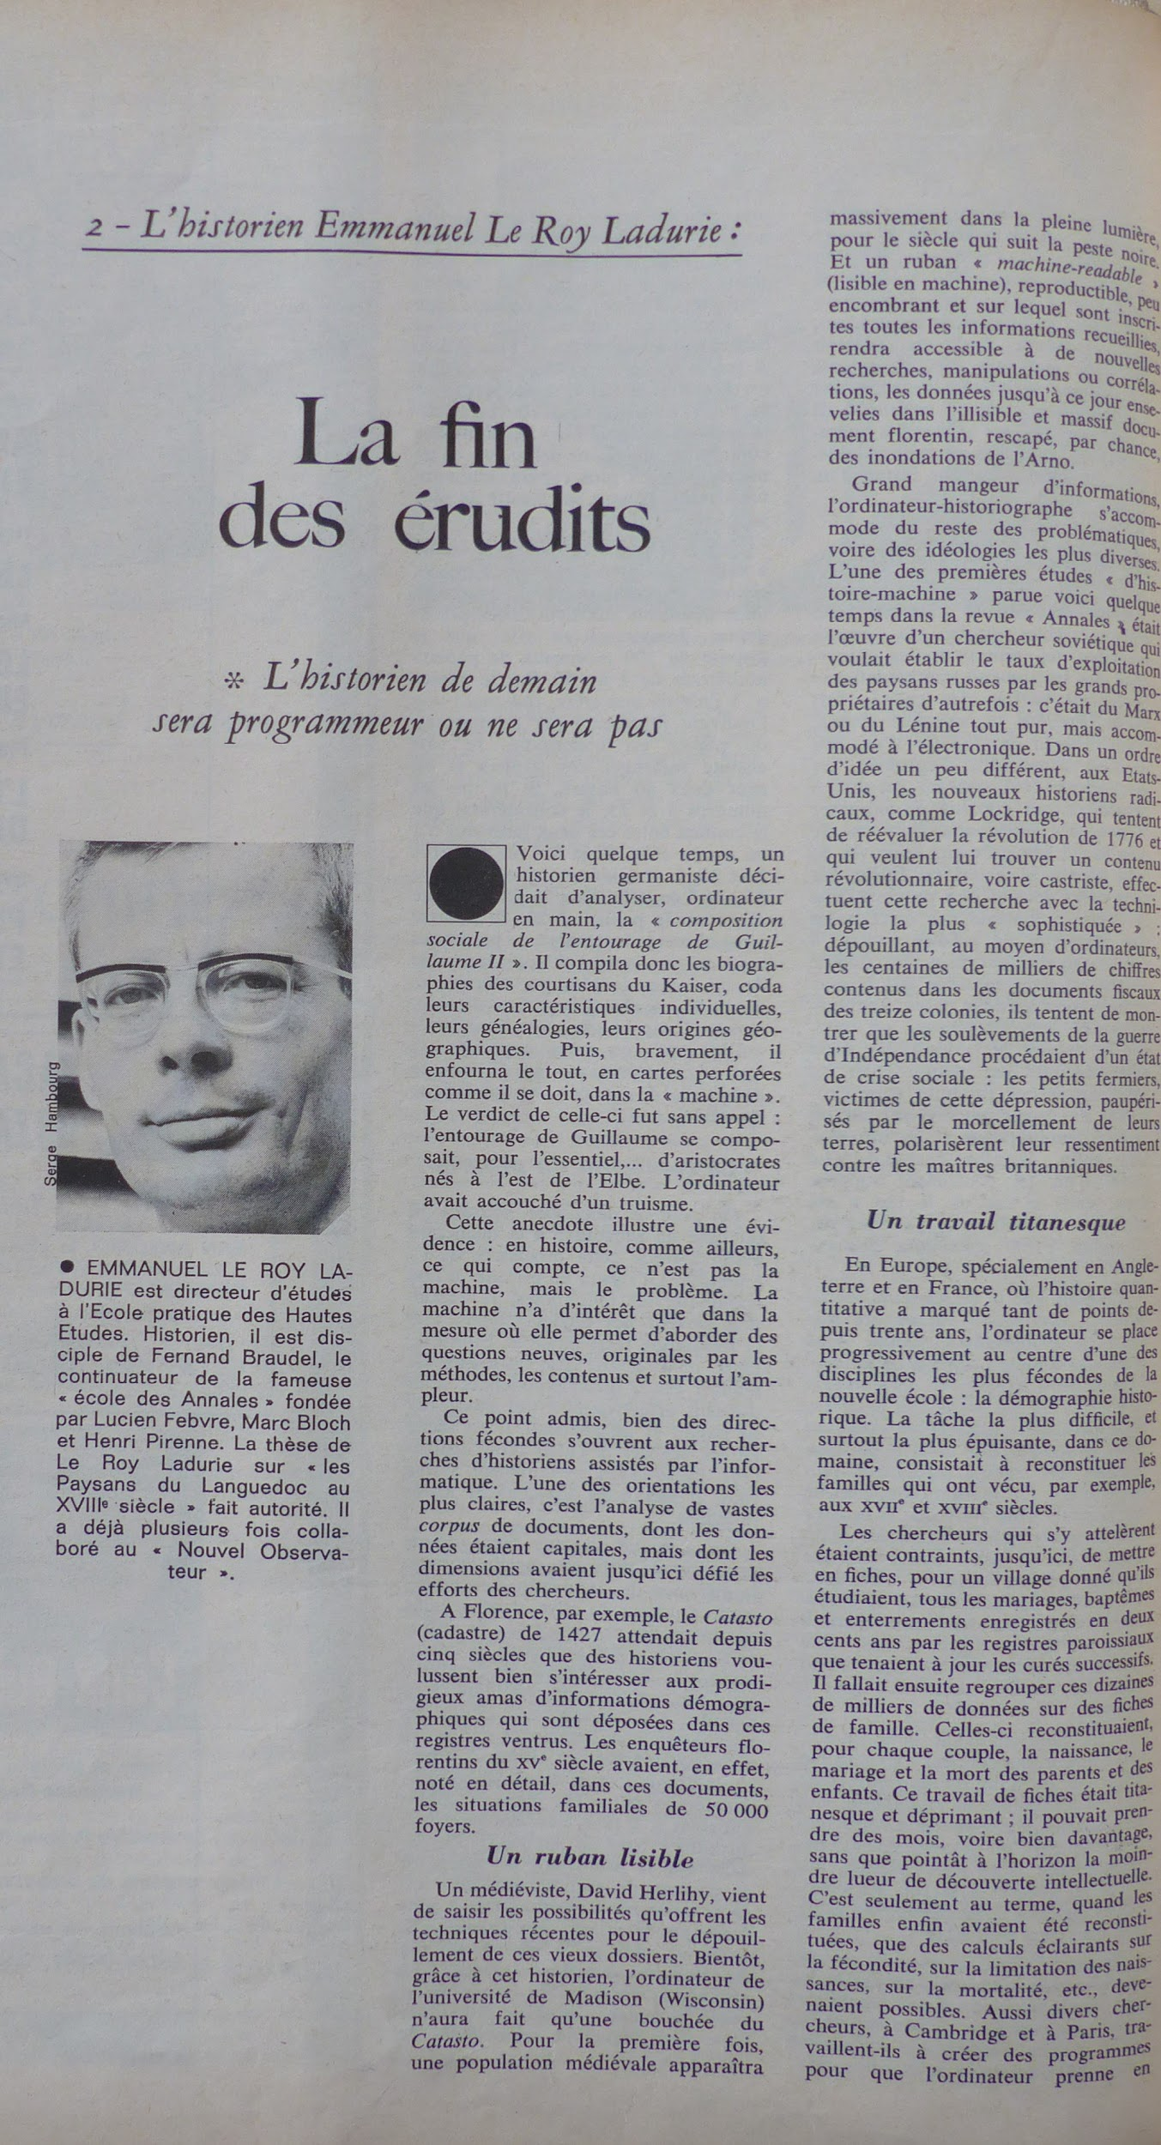

Figure 28. The article by Emmanuel Le Roy Ladurie, "La fin des érudits", published in Le Nouvel Observateur, 8 May 1968.

Tarah McPherson suggests digital humanities should have “at least a passing familiarity with code languages, operating systems, algorithmic thinking, and systems design”. She goes on proposing a combination of “database literacies, algorithmic literacies, computational literacies, interface literacies”. (McPherson 2011, 35). McPherson is among the most militant voices in this critical turn, and also argues that we do not need to become computer experts, but it is necessary to acquire the capabilities to use the digital affordances and to criticise, properly, the digitally mediated work; I reckon, to do it thoroughly, at the same time, a self-reflexive approach is a must. In this direction, I very much like Berry's quest for a *super-critical-thinking* “that is generative of ideas, modes of thought, theories and new practices” (Berry 2011, 08).

On paper, these ideas do not seem so complicated, and literature may not be as abundant as the previous phases of digital humanities, but it certainly provides terrific insights. However, to ensure a truly far-reaching critical turn beyond the practice one, aiming at a glocal perspective, we need more than ideas and qualified people – assuming something different would mean that many great scholars around the world are not producing digital scholarship good enough simply because they are, somehow, of lesser intelligence. That is not measurable, but for sure, we can logically enough discard such a generalisation of dumbness. I suppose, on another perspective, that the most challenging ingredient here is a specific context to allow this turning point; a special context that could permit the most favourable circumstances to be met for ensuring critical work under the interferences and conditionings of the digital.

In other words, a *crucial context* in which an emerging style of reasoning could mature and blossom; reasoning that, as I contend here, is intrinsically anchored in the pedagogies of building and doing – hence, hands-on work and thinkering. We will, of course, need people (and to train more people) and ideas, but, we will need them to be organised in a certain environment, in a certain way, endowed with certain resources and, last but not least, tuned in to a certain mindset. Here again, I think about Certeau's cautionary call about the "double function of the place" (Certeau 1988, 68). Of course, the greater and fairest circumstances depend on funding as well, which can be as uncontrollable as the team mindset or tomorrow’s weather, however, if we know in which direction we want to go, we can aim for the fairer and look out for directional guidance.

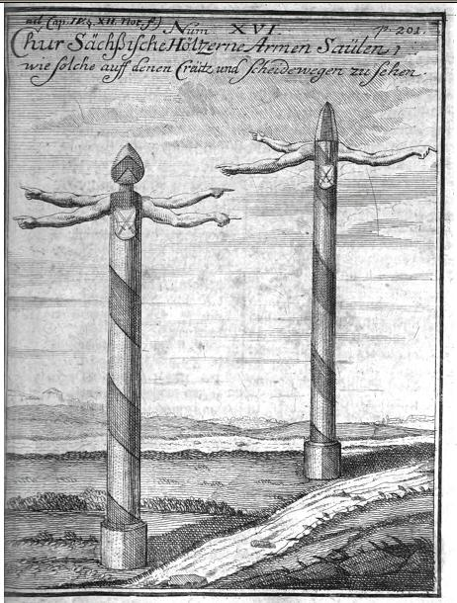

Figure 29. : Illustration. Wooden Fingerposts, Source: Saxonia monumentis viarum illustrata 1726, by Carl Christian Schramm. Wikimedia Commons.

Harmoniously combined, and actively shared within the involved *communities of practice* (Wenger 2000; Klein 2014) the above mentioned – ever-evolving – technical skills and engaged critical thinking – that, in its turn, characterises historical thinking – could develop into being a powerful *practical*-*analytical* virtual apparatus for historical research in the digital age[13]. I believe that the application of such *practical-analytical* ways of making digital history already exists, although, still seldom and scattered in the digital history scholarship realm. In his study about the trading zones of digital history, Max Kemman, for instance, identified some *digital history brokers* among the historians who, at a micro level collaboration “chose to engage intensively with computational experts” and “who exemplified significant shifts in practices” (Kemman 2019, 30)[14]. From Kemman’s studies, we can read digital history brokers as great team players within the project framework:

Brokers conducted project management; coordinated practices from archival and library domains such as data collection, transformation, and description; learned about the potential and limitations of computational technologies and where to apply these; employed inter-languages to translate between the different collaborating domains; and finally transformed historical questions into infrastructural problems. (Kemman 2019, 30)

To bridge the gap between *thinking* and *doing* and dissolve the apparent opposition between hack and yack it seems necessary to create circumstances that allow emerging practices to be significantly shared among historians in the ranks of digital history; such is the *crucial context* in which an emerging style of reasoning could, perhaps, emerge and authenticate itself.

Arguing with Kemman, this is a job for brokers, to unite the two-sided trading zone of digital history – the computer experts (the *digital*) and the historians (the *history*). Kemman divides the interactions between the *digital* and the *history* in three levels.On the macro level of engagement with computer experts, Kemman suggests that “historians” would refer to “the entire discipline as a global community of practice” (2019, 200). On this level, infrastructural tensions were not (yet) solved and “rather than transforming historical scholarship, the challenge is to provide infrastructures in a way that fits existing practices”. Historians in this level of interaction, hence, are arguably not the most likely to apply the *practical-analytical* way of making digital history; they rather stick to the current practices where this gap persists. On the meso level, “historians” referred to “all historians engaged in trading zones of digital history” and “the effect of interactions was dependent on individual decisions and incentives.” (idem). On this level, however, due to individual subjectivities – i.e. attitude towards risk taking, preference to maintenance of disciplinary practice – after learning new practices, historians remained aligned with traditional practices, “changing practices were regularly not in the direction of computational practices, but to incentives of politics or funding.” (idem). And, finally, on the micro level, “historians” would choose to “engage intensively with computer experts”, hence, this seems to be the most suitable level of interaction for the emergence of digital history brokers and significant shifts in practices.

Kemman was my first office mate at C²DH, and in his study, he saw the potential of digital history brokering in an environment like C²DH. However, the readiness to brokerage would not just “happen” homogeneously through projects and teams, it would still depend a lot on individual choices and subjectivity. Hereunder, drawing on Kemman’s conclusion of digital history brokering as *infrastructuring* I will attempt to illustrate what I believe, could be the *crucial context* for the emergence of a shared collection of practices that could help to fill the gap between *hack* and *yack* and support the advance or democratisation of digital history scholarship in a more sustainable way – through, perhaps, the establishment of a new style of reasoning – rather than through the detachment of isles of innovation and brokering. C²DH could be judged by some as this sort of isle. However, I believe that C²DH’s brokering emerged from the great interactions between old and new practices that found a home there because the centre brings together a critical mass with an overture and encouragement to experimentation and hybridity.

Moreover, C²DH’s management team was determined to make room for and support the playful, creative and critical association of old (analogical, offline) and new digital skills for historical research. Beyond counting on the support of the Digital History Lab, team trainings, a series of lectures, workshops and even special prizes were created to inform and incentivise the hands-on and thinkering approach[15]. With the label of *laboratory of historical uncertainty*, C²DH entered the map of digital and digital public history not as an isle of innovation, but as an *agora* at the very *crossroads* of tradition and innovation, analogical and digital, old and past practices. We could think of such crossroads as the incorporation of the *hermeneutics of in-betweenness* (Ramsay 2011; Fickers 2021). These crossroads inspired me to propose, hereunder, an exercise of imagination to reach the *crucial context* in which a new style of reasoning could emerge. The metaphor of *crossroads*, in this case, comes with the encounter of (at least) two main *roads* that we shall read as vectors to achieve the most favourable circumstances for what we aim as a crucial *context*[16]*.*

### *A crossroads for digital history scholarship: heuristic triggers*

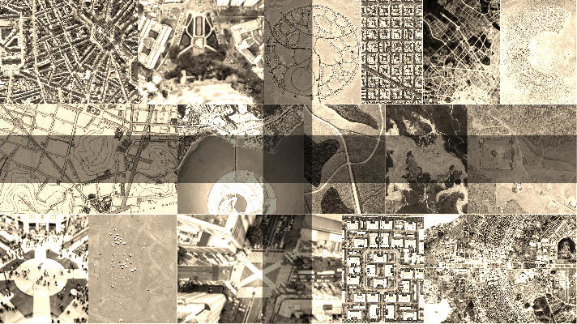

Figure 30. Illustration, “Encruzilhadas” (Crossroads). Photo collage of sixteen different types and designs of crossroads around the world. By Barbara Menezes

By summoning the metaphor of crossroads and the idea of a *crucial context* here, I do not mean we can reach a guaranteed solution. I aim, pragmatically, at an ideal scenario. It is very unlikely that my imagined crossroads for digital history would be feasible everywhere because there is a wide range of uncontrollable issues that do not depend solely on the researcher. Moreover, we have not yet seen a model that could be considered a “success formula”. The heterogeneity of practices, institutions and project designs is so vast and positive for research that it makes it hard and maybe counterproductive to sketch a “roadmap to success”. In every country and local context, realities bring different possibilities and constraints. In Brazil, for instance, there is no currently institutional environment with some kind of organisation (i.e. study group, lab, centre) dedicated specifically to digital history. As Dilton Maynard recently noted, in Brazil, most of the experimentation is happening in the context of teaching activities, hence, in his view, classrooms of basic education could be considered the *true laboratory of digital history in Brazil* (Maynard 2019). What I propose is not a manifesto or code of values, but an exercise for us to think about what pragmatic conditions could favour digital history scholarship to flourish. In short, I handle these crossroads rather as heuristic triggers than universalising solutions or values. Hereunder, a few prompts:

1. **Openness***:*

Openness can be presented in manifold ways, but I emphasise two, which I believe, can help to further promote this openness First, it is fundamental to share details about research processes, and this should become more recurrent and systematic. Results, even when accompanied by eventual codes and datasets are not enough without the due contextualisation. In the same way metadata is important to seize any digital material, a critical thick description of the project development context(s) is paramount to the understanding and appraisal of digital scholarship. Understanding the researcher’s positioning and subjectivity, being aware of some of her/his idiosyncrasies and having a record of some important decision-making processes along the way might seem unnecessary to research methods that are rather established and have one or more stable frameworks to refer to, but in such a shaky ground like digital history, the more [contextualisation] the merrier; hence, in Chapter 2, my plea for a movement of *documenting the process*. Secondly, the background of this ideal context needs to be one of open science, not only in terms of access and circulation of knowledge but also in terms of mindset and the abouts when/where/who in the production of knowledge. And from here we shall turn to *public history*, and the role of historians in the public space. What does it mean to be *out* and *about*? Much has been discussed among public historians, but I believe that a fair starting point for this answer is about the willingness to be open and public – scholars at this crossroads can no longer remain isolated in the Ivory Tower, they must be alert – looking at the fast traffic around them, the bypassers, the ordinary life. In this metaphor, they need to pay more attention to the surroundings beyond their personal worldviews and institutional values, not only what they can see from the top of their very own towers, but to seek other perspectives and alternative paths.

1. **Collaboration***:*

Improving existing and enabling further *trading zones* in digital history[17] where historians can, more and more, learn from computing experts, designers, data scientists or other communities of practice about the aspects of their digital work that go beyond the strictly historiographical expertise (e.g. technical/computational aspects, like how to install a Content Management System or how to pre-process a corpus for text-modelling, but also more sociological and cultural features that many historians' may not be quite acquainted with, I am thinking even about communication and marketing – like Search Engine Optimisation strategy – or even project management). As I tried to demonstrate in the description of Memorecord, collaboration was crucial to the accomplishment of the platform and enabled me to grasp many elements that seemed way too far from my previous research experience, that was not done in public, nor in a collaborative environment and had no room for hands-on working. For instance, I could learn from a colleague how to run script to update the website gallery, but I could not write the script from scratch. There are, thus, some parts of the work that can be shared and others that will be mostly carried by the experts, however, by working closely together, fewer parts of this work will be at risk of becoming alien to the researcher. Collaboration should foster iterative work and provide safety nets for experimentation. In such an environment, the porosities between disciplinary boundaries can widen and favour either development of more *boundary objects* or better conditions for *interaction expertise*. Finally, imagining the multiple digital artefacts originated from digital work as boundary objects could actually be fortuitous to scaffold the heterogeneous work setting and mitigate the conflicts that might arise from the diversity of viewpoints and *power relations* within the trading zones.

1. **Infrastructuring**:

Create infrastructures that enable and maintain the collaborative digital work on an everyday basis. This means that infrastructures should be considered as essential to the very existence of digital scholarship and, therefore, meditated and put in place beforehand, but with flexibility and agility to be constantly improved in an ongoing process, able to adapt to the everyday needs, according to the state of the art as the research unfolds. This should consider the inherent *updatism* of digital culture and try to keep pace with the inexorable trap of obsolescence around the corner. This is no antidote for mutation or discontinuance of technology but should help to mitigate the pitfalls of obsolescence, at least at short-term projects level. But we can always look up to the greater situation, it does not mean we need to solve all the problems on the horizon of preservation, for instance. Hoewever, we can seek for better practices, especially in respect to issues that have been in the margins of digital projects, but pose an imminent threat to their maintenance, like obsolescence. Yet, infrastructures need to be taken into consideration beyond their technological aspects, looking into their *appropriation in communities of practice* and how this affects the *embedding of practices*. To put it another way, infrastructuring deals with the *technological feasibility* and *social readiness* that ultimately allows scholars to engage meaningfully with the digital. For example, in the natural sciences, no Principal Investigator would hand the keys of an empty lab to her/his team and expect they could actually work and achieve meaningful results before equipping it with the necessary tools and supplies. But, equally illogical – although it happens more often than researchers would like – would be letting the team motivation and skills, as well as the tools of this lab, to be overwhelmed by the fast development of techniques in a certain domain, risking to become so outdated that the lab could detach itself from the moving field. That is a rather dramatic view, but realistically, in the digital humanities domain, the ever-evolving nature of the field and the lack of infrastructuring, bringing together the mental and technical readiness, can be the cause for projects to fall apart. Of course, this again is a variant of the context that depends immensely on funding and mindsets but could be tempered by a strong and coherent strategy to ensure infrastructuring.

1. **Training & Evaluation:**

To a certain extent, training and evaluation *for* and *of* digital scholarship is *infrastructuring* to the crucial context we aim for. The *great many novelties* arising with the digital turn introduce needs for new skills that we can think in the lines of *multimodal literacies*, and this is yet to be sufficiently covered in traditional training. Not only we need to plan the systematic introduction of new teaching contents in all levels of higher education, but we should update the evaluation criteria to take into account the multiplicity of formats and different engagements of scholarship with the digital. Here again, we can turn o the public history component in digital public history projects as well. The possibilities of new forms of research and storytelling brought by the digital and ease of engagement with the various *publics* and *audiences* of history are still left out of curricula in most of the cases. On the one hand, while public history as a practice has been around even before its labelling in the 1970’s, the many specific aspects of this practice remain still relegated to the margins of specialisation. On the other hand, for obvious reasons, the newness of digital work has never been addressed, neither in contexts of specialisations, until very recently. The last three decades still have to be processed and digested into new models and topics for teaching and their respective evaluation criteria need to be standardised and macroscaled[18]. And, ultimately, if we wish that the new digital scholarship we are producing gets thoroughly credited (i.e. aiming at digital work being indeed considered in its full capacity for academic tenure) the changes need to happen at regular training, since Bachelor levels, including Masters and professional Master programs, as well as in Doctoral Schools, when in place, and other forms of internal trainings for faculty members. This could help to endure standardisation of methods and the formation of a critical mass practicing. Reflecting on it, this training is not a magic formula, but it could be seen as a pragmatic way to enhance the friction between more pre-digital traditions and the novelties at stake. Hopefully, this could be a program for the *hybridisation* of historical training and studies[19]. For the recognition of digital scholarship the long gaze at a possible new *style of reasoning* of/about/in/within digital and digital public history would be worthless if after attempting to grasp the sense of all the aforementioned changes in practice and ways of thinking, the assessment of the processes and results of research should submit to old evaluation instruments.

My attempt with the above suggestions for the *crucial context* is less of a pamphleteer and prescriptive discourse, though it sounds a bit like this, than an exercise of imagination in favour of establishing **what we do when we do digital and digital public history as a commonly shared form of scholarship**. Hereupon, I prefer to deal with challenges entailed by the digital under the rubric of the **interferences** and **conditioning** they spawn, trying to propose a diagnostic (i.e. interferences as symptoms, what are the conditioning elements?) and a way out in a more pragmatic stance. Addressing challenges from this perspective, I believe, does not mean simply becoming aware of what the challenges are, and promoting theoretical debates about them, but also speculating on possible compromises between what would be the ideal solutions and the more realistic, practical alternatives to devise an action plan. This is a first level of what I want to develop as the **hermeneutics of practice**. Under the overarching hypothesis that we could be witnessing the emergence of a particular *style of reasoning* of/about/in/within digital and digital public history, what can we do to prevent digital history scholarship from falling apart due to the blurring on methods that only those inside our micro level of interaction are able to understand and, for many, not so entirely?

# On hybridisation

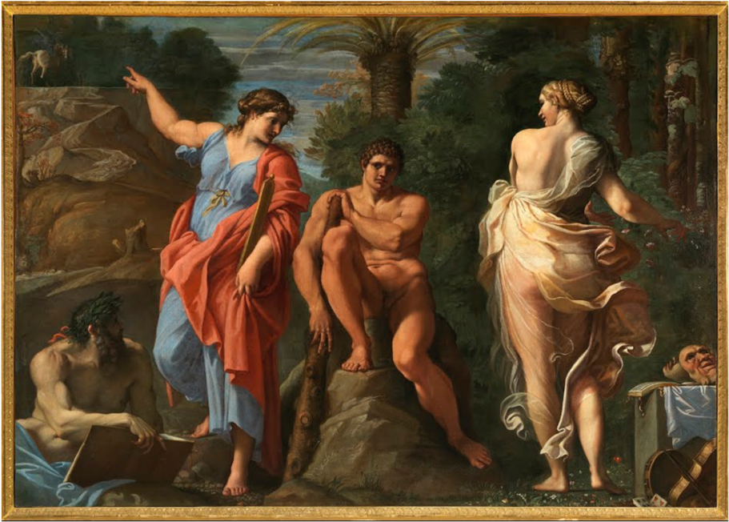

Figure 31. Hercules at the Crossroads, Annibale Carracci, 1596 (oil on canvas). Museo e Real Bosco di Capodimonte. Click to view on Google Arts & Culture.

The contribution of Gerben Zaagsma to the debate I have been drawing on so far is incommensurable, as announced in Chapter 1. In 2013, Zaagsma introduced the notion of hybridity within the discipline of history itself. While in digital humanities the idea of hybridity seemed to be somewhat related to interactional work, cross-disciplinary, cross-boundary, in his text *On Digital History*, Zaagsma argues about a hybridity that could take place inside the historical community of practice itself. Pragmatically, he points out the need for bringing together and equalising our old and new sets of practices, reviewing his own:

The current challenge facing the discipline of history is not in creating ever bigger sets of data and developing new tools, important as these are. The real challenge is to be consciously hybrid and to integrate ‘traditional’ and ‘digital’ approaches in a new practice of doing history (I realise that the concept of hybridity might underscore the dichotomy I have argued against earlier, but it seems to me a necessary sensitising concept to accompany the conscious mental transition that I deem so important). (Zaagsma 2013, 17)

Hybridity, here, is a projection of a scholarly persona whose curriculum would be a mix of skills and competencies to face the challenges of the everyday practice of digital work but also capable of dealing with rather long-term issues, scaled up to norms and standards beyond oneself, entangled not only with the tradition of a discipline, but the whole array of humanistic studies and cultural heritage in the digital age. Under the spectrum of daily digital work, hence, there are yet other forms of hybridity than the one imagined by Zaagsma. The conjugation of established offline/analogue methods and the new online/digital ever-evolving practices, with its tools and methods, also inspired the projection of an offspring of two distinct professions, the most obvious and explored being the figure of a *programming humanist*. However, zooming out from the frugal activities, there are needed competences, connected to the digital, but yet, not dependent only on programming skills. McPherson targets these other holistic profiles and suggests the need for an awareness that before being technical, is an ontological preoccupation:

We need new hybrid practices: artist theorists; programming humanists; activist scholars; theoretical archivists; critical race coders. We have to shake ourselves out of our small field-based boxes, taking seriously the possibility that our own knowledge practices are "normalised," "modular," and "black-boxed" in much the same way as the code we might study in our work. (McPherson 2011, 35)

Hybridity, hence, is also a meeting place of different traditions that we could see as another crossroads. Within the discipline of history, however, hybrid work does not seem to have a long or successful past. Under the interdisciplinary awareness postulated by the *Annales*, in their search for a new approach to study history, other disciplines would remain relegated rather to the role of an accessory science, from which we would drag some practices, than to a real potential hybrid crosser. However, the hermeticism of historical methods were denounced. In 1929, Marc Bloch and Lucien Febvre, the founding fathers of the journal and movement, wrote about it in their first editorial: “But the walls are so high that they often block the view” (Bloch and Febvre 1929)[20]. They appealed for a more encompassing humanistic outlook for writing a history that should be problem-oriented, rather than story-oriented. "The new historians, – on Peter Burke's reading – would be consciously interdisciplinary, drawing ideas and methods from geography, psychology, sociology, social anthropology, linguistics, and so on." (Burke 2001).

Alan Liu chiefly remembers that digital history emerges in a discipline that already has a past with numerical methods, precisely, the quantitative side of *Annales* school and cliometrics (Liu 2013, 412). This is the pre-history of hybridity for us. However, it was not due (only) to it. Arguably the hermeticism and provincialism of what was back then the new quantitative methods of New Economic History ended up with a resounding rejection and embarrassing distinctions, such as the one between “economic historians” and “competent economists”. Controversial debates on the perks and pitfalls of cliometrics continue to this day. Despite the hype, digital history also gets its refusal, in 2012, a panel on the #DHLU symposium[21], Thomas Nygren described digital history as a *bastard*, "it is not true history", because it is just about the acquisition of learnable techniques[22]. Could digital history be subject to a similar ostracism as that of cliometrics at the end of the past century? What do we see in ten, twenty, thirty years from here? Which are the new ways of digital humanities with the ever-growing – I am sorry for the pleonasm – ubiquity of computing technology (Ekman et al. 2016; Carter and Nielsen 2017)? Will we make history with Artificial Intelligence robots (Nicodemo and Cardoso 2019)? Is there a risk for the trading zones of digital history to be deserted by the lack of recognition of our scholarship? But in such a case, would historians keep doing scattered research and lacking a common language to discuss digital methods in its ontological, epistemological and ethical dimension? The serious open question is not *if* we will do research *about* and *by* means of the digital, but *how*.

In the opposite direction of a fatalist scenario about the *end of history* or *the end of digital history* and any variation of these formulas that seek to empty the very meaning of history, the metaphor of crossroads is warmly welcome here, despite the use and abuse of it elsewhere. Crossroads embodies the concepts of *division* but also *encounter,* and it might be common sense, but it also evokes the ideas of *decision making* and *moral quandaries,* as well as *turning points* – *I am at a crossroads, what should I do*? *Between A and B, which way should we go?* Or, yet, if it is difficult to choose, we could stay, hang on a little longer, expecting that an eventual fortuitous encounter could help to solve our dilemmas. I believe historiography is still facing a dilemma of whether to fully accept or reject the digital. The tensions between tradition and innovation are still strong in digital history debates. I would argue that instead of altogether rejecting one or another, we could profit from the metaphor of crossroads to open a *chantier* right in the middle of it where we could work out alternative ways to go on when none of the existing ways seem very attractive. Experimentation is the *building site* of alternative ways of thinking in the middle of our crossroads. And hands-on work is the necessary experience to elicit these new ways of thinking, without rolling-up the sleeves, there is no *thinkering*, only detached thinking and as I try to stress throughout this thesis, *doing* and *thinking* need to walk hand in hand. Only through thinkering, will it be possible to augment our senses in order to detect the digital interferences that conditionate our digital work.

Crossroads, moreover, serve as a constant reminder of the *intersectionality* of our work. The term, was coined more than thirty years ago by Kimberlé Crenshaw, in the field of critical race theory. It was originally mobilised as a key to understand and explain the oppression of Black women, “[b]ecause the intersectional experience is greater than the sum of racism and sexism, any analysis that does not take intersectionality into account cannot sufficiently address the particular manner in which Black women are subordinated” (Crenshaw 1989, 140). For its theoretical vigour, Intersectionality, has been adopted as *analytical tool*, *critical inquiry* and *praxis* (Hill Collins and Bilge 2016) tackle the critical articulations of the categories race, gender, class, ethnicity, and sexual orientation in dialogue with long-standing, but ever urgent debates on human rights and most recently the policy of equality. Sociologists Patricia Hill Collins and Sirma Bilge contend that as an analytical tool, intersectionality helps us to understand the complexity of the intertwined power relations among these identity categories and, as critical inquiry and praxis. Intersectionality is an important stance to interpret how groups, individuals and institutions are playing a role in the arena of identity debates and how it may foster praxis. Intersectionality, furthermore, is a promising academic and political concept for public history (Graves and Dubrow 2019).

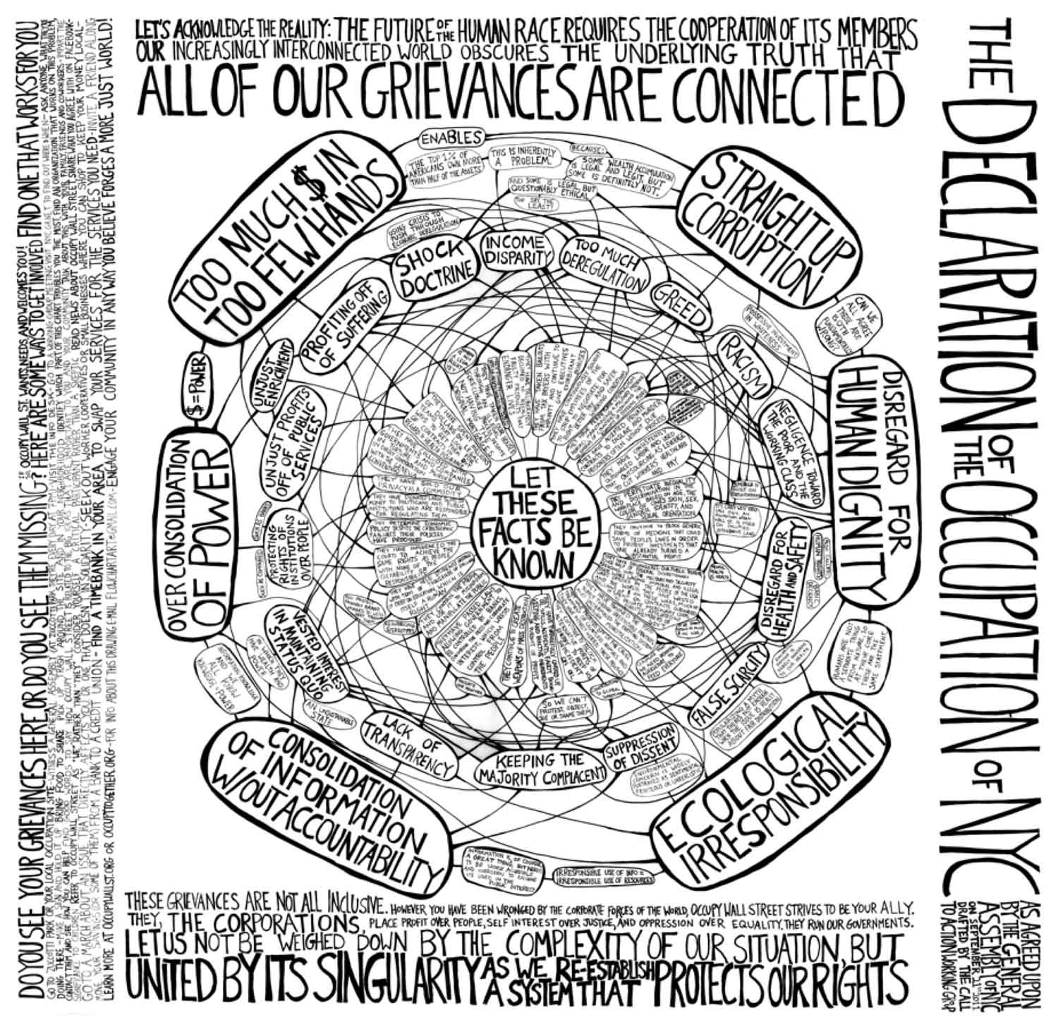

Figure 32. Intersectionality. Flowchart of the Declaration of the Occupation of NYC, Rachel Schragis. Go to zoom.it for the [zoom view of the chart](http://zoom.it/MFXB#full)[23]

One of the flagrant challenges brought by the digital component to the research in the humanities, and hence historical research too, is the “the fraught relationship between digital humanities and diversity” (Risam 2015) or, putting it in another way, “the meaning problem”, as Liu called it (Liu 2013). The problem or challenge inferred here could be shortly explained by the obliteration of cultural critique by significant but almost tautological debates on the definition of *what is* or *is not* digital humanities (especially in terms of methods) and *who* *is inside or outside* (especially in terms of technical skills), as expounded by Katharine Bode and Paul Longley Arthur in their sharp introduction to the 2014's volume *Advancing Digital Humanities: Research, Methods, Theories*. The volume advocates for pushing the field ahead “overwhelming definitional debates” in order to “show, rather than describe, what digital humanities is, what it can do, the contribution it makes to humanities research, and the role it can play in the future: its research, theories, and methods” (2014, 03).

## Working in the trading zone of Digital History

Crossroads are nothing but a materialisation of trading zones. What I suggested above as *crucial context* for the development of digital scholarship is a pragmatic stance towards the desirable advancement Arthur and Bode argued for. It is not necessarily to move past the *digital-* (-humanities, -history) identity self-interrogation, but to incorporate the possibility to think hermeneutically along with it, in a fashion that could be shared within its community of practice and beyond. Once we could stop the simply redundant definitional debates, we could go back to hermeneutics. This would mean paying more attention to interpreting processes, in a meta-level, or interpreting objects or subjects with the goal of offering a historiographic critique. In this context, we could keep creating digital artefacts, but interpreting and historicising its own building by means of experimentation, and we could claim it as a form of scholarship too, the historiography of digital history. We could also study other (digital) objects and subjects using digital methods, and claim this is scholarship too, the practice of digital history. Herewith, the self-reflective posture could still carry open questions in terms of *who we are*, *where we go*, and that is no sin. However, to move forward and contend outwards that what we do is still history, it is fundamental to pursue, as well, a reflection on the ontological and epistemological implications of the digital interferences and conditioning in our contemporary production of history. Otherwise, we could be damned to a superficial criticism that could lead digital history to a similar fate of that of cliometrics – one of technical obliteration of our humanistic inquiry and the consequent detachment of the rest of the discipline.

In the opposite direction, incorporating an updated set of skills, both in terms of technical and mental apparatus and sharing it more thoroughly beyond our micro level interactions, breaking through any risks of hermeticism, what we do could come into being the emergence of a *style of reasoning*, in line with Hacking. Making this style intelligible *to not so close* peers, would need to go through a process of self-authentication (Hacking 2004, 191) that includes the definitional debates but also the affirmation of the new objects and new ways to grant standards of objectivity iteratively. Digital hermeneutics, as described by Fickers, seems to be the way to reach a certain standard of objectivity. Fickers describes digital hermeneutics as follows:

A set of skills and competences that allow historians to critically reflect on the various interventions of digital research infrastructures, tools, database and dissemination platforms in the process of thinking, doing, and narrating history. (Fickers 2021)[24]

It is essential to consider that in history, that standards of objectivity may not be so objective as a checklist to assert truth or falsehood, it is instead a responsible approximation to the truth, taking into account that all interpretations are subjectivist. Nevertheless, we can consider digital hermeneutics as a step towards this approximation if it succeeds in revealing and assessing all the biases and interferences the digital imposes to research. As Franklin Rudolf Ankersmit contends, "the most pronounced subjectivity is the condition for the highest degree of objectivity" (2005, 103). Hence, we can think about digital hermeneutics as an exercise of digital biases detecting, of scanning our digital work, in its full capacity, to identify and reflect on its interferences. There may have no formula to follow, but the constant awareness about the digital interferences could prompt a holistic habit of flagging the encountered biases.

Furthermore, we should consider that the digital interferences are not punctual, but intersectional, within other expertise in the trading zone, and transversal/iterative regarding the different layers of the digital work. In other words, for historians to be accountable for a *responsible approximation of the truth* in the digital age, they need to “know how the tools and the algorithm behind them work to avoid falling into traps that can lead to serious distortions in historical research” (Oberbichler 2020b). In a practical example, historians should not assume that machines have the same reading skills than a human being. Sarah Oberbichler has a very instructive example to illustrate this problem with respect to text-mining tools working with a collection that they might simply interpret as a bag of texts:

Imagine texts are like medical pills. They have an active ingredient (core meaning or even several core meanings) which takes up a tiny part while the inactive ingredients cover three-fourths of it. If we have a handful of different pills without knowing what they should be taken for, they are not very helpful for us. As humans, we would try to identify the active ingredient of the pill (by using context knowledge) in order to group the pills with similar effects (not similar ingredients). To understand that similar ingredients are not the same than similar effects is one step towards effective digital source/tool criticism. Unsupervised, text mining tools would very likely sort pills in a different way than humans if all that they have is a list of the ingredients. They would group those who have the most similar combinations of ingredients, and it is likely that this results not in a classification of pills with similar effects. (Oberbichler 2020a)

The holistic exercise in this context, thus,is always to have in mind the detail and the big picture of a project and consider the mutual shaping of context, content and technology, as well as the historians’ tampering over it all. The advantage of trading zones, in this case, is the possibility to seek help with experts when even after reading technical texts you could still not make sense of it due to language barriers or black-boxes that become harder to break when you have not accumulated the basic range of *tacit knowledge*[25]. In my case, during the conceptualisation and creation of Memorecord, I found that face to face conversation and quick chats around the laptop, in a sort of quick, punctual *talk and show* tutorials, proved to be more effective than online communication with my collaborators. To me, the local trading zone is a further advantage because, in some cases, due to computational capacity and permissions – i.e. if a developer tool is missing in your machine it could create chains of dependencies that prevent a specific task to be seamlessly concluded by another app or package manager; or yet, if you do not have granted remote access to a specific server, it will make distant collaboration tricky. Since outside collaborators could not obtain access to certain environments by themselves, getting in touch personally made things far easier than working through text and screenshots. Many times, at the beginning of Memorecord's development and tests, I asked my computer expert colleagues for help to update or install tools in my laptop. Since I worked more closely with Daniele Guido, as described in Chapter 2, sometimes I could go to his office and watch what he was doing simultaneously on the screen. Other times, I could try a few things by myself on my laptop with him offering some guidance by my side. After a few rounds of this mentorship, I was so glad to hear him say that I did not depend on him anymore. However, it was not totally true, I did depend on his occasional advice, though I had just acquired enough tacit knowledge to keep going until a next level bug would stop me.

Digital hermeneutics should, hence, help historians to note that a specific feature of a tool or a particularity of data could bring about noises elsewhere in the interpretation of a given situation. I tried to demonstrate these intersectional characteristics of the digital bias in Chapter 2 when discussing how each choice on the process of building Memorecord made a difference. But also, how, after selecting specific tools, I had to continuously adapt the project around certain conditions of it, entailed by the tool’s logic. During Memorecord’s community sensitisation phase, I learned that my initial idea of using a WordPress-like portal to host the harvested memories was not appreciated by participants. I then took the decision to work with social media networks, but the retrieving of posts and metadata from Instagram and Facebook obliged me to create two different web scraping tasks that resulted in the extraction of a diverse range of metadata for each source channel (Facebook and Instagram), meaning two sub-collections with not fully corresponding metadata. Moreover, while Instagram allowed the direct scraping of posts from users’ profiles, Facebook only allowed the scraping of posts shared by pages, not by individuals, forcing me to add an intermediate manual task where I would share individual's posts on Memorecord's Facebook page before the automated scraping could take place. It did not have a tremendous impact in the analysis because the metadata available, after all, is still similar and despite the non-coincident terminology it was still possible to make sense of it in a close reading experience. This interference, however, entailed more manual, time-consuming work and generated some inconsistency in the metadata. Since Memorecord did not result in a huge amount of data, it did not bring further problems to the analysis, but if I depended on distant reading to process the data collected, I would have needed to manipulate the metadata names to mingle both subcollections artificially.

A common anxiety among historians in regard to projects like Memorecord or other initiatives, for instance tools for data analysis with heavier computational power running behind (i.e. Mallet package for topic modelling), is the fogginess around the many technological black boxes and the uncertainties it brings about. Some may criticise that we cannot trust digital media because we cannot fully assess algorithmic bias, for instance, but this should not stop us from thinking about it. Otherwise, we might be risking losing a significant parcel of cultural heritage material and human traces in electronic forms that are most valuable to the study of the history of our present time. Let us imagine how critical this picture could get in fifty years from now. With a new *style*, we could reach a compromise in terms of protocols and standardised practices, less to enforce a rigid *step-by-step* guide for historiographic critique in the digital age*,* but topinpoint a few reference signs to aid the navigation through the fogginess. Hence, creating a habit of flagging the interferences we encounter in our digital work and critically reflect about them would favour a situation in which historians could, more efficiently, share a corresponding analytical-technical apparatus that, ultimately, could become a common ground for digital work.

Digital hermeneutics, thus, could be held as a common practice among digital historians, but with clear enough shared standards that allow historians, from within and outside the digital history trading zones, to fully assess the work of their peers despite the fogginess. Having reached a collective basis, which I want to think in terms of the popularisation of a particular **style of reasoning of/about/in/within** digital and digital public history, I believe, it could lead to more engaged historiographic critique and less detached tautological discussion on methods and definition. In other words, this could allow us to conduct historical research despite the uncertainties.

This movement could ground digital history back in its primary terrain, that of thinking historically about societal and cultural inquiries, where historical thinking is “to attribute a constitutive meaning to the temporal distance between today and yesterday”. (Landwehr 2012, 09). In this sense, reasoning *about* digital history means we could reflect, in a more accessible way to the wider community of practice within the discipline of history, about the historicity the digital component carries, be it as an electronic gadget, a piece of software or as a sample of data. Interrogating the new digital *technologies of memory* considering its historical development, hence, could be an object of digital history. Likewise, if historians are interpreting specific memories of a historical event or phenomenon using digital methods, this could be considered part of a specific reasoning *of* digital history about those memories. In both scenarios, the digital may still entail some fogginess, because it feels alien to us since we cannot fully control it. However, if we can be fully aware of the digital interferences in our research, this should not prevent us from working with/on it, after all, why would the past be considered less alien to us when we try to assess it by analogue means? Perhaps, the only difference here is the historicity of digital methods itself and the fact the historians are much more accustomed to conducting research analogically, but this does not make the instruments of that method of lesser subjectivity than those of digital methods. They are just different subjectivities.

## Digital component as a condition

Insofar, the above-mentioned imbalance between *doing* and *thinking* in the digital humanities realms – including digital history – has been a hindrance to the sharing of a desirable *practical*-*analytical* apparatus. To some extent, we could attribute the struggle of digital history scholarship to establish itself as a valid genre of scholarship due to the discredit it gets among historians that, somehow, still distrust digital methods without giving it a chance or those who still struggle to understand it, despite having engaged with it already, be it as an audience or an author. Hence, the debate for defining digital history goes on, while digital history still lacks a standardised inventory of practices and, consequently, a coherent shared critique base of these practices. My point is that although there are still some pessimistic attitudes about technology as a whole, the persisting sceptical outlook from colleagues is not always wired by cynicism, but partially rooted in the lack of a common groundthat could be seamlessly shared and help to organise and stabilise the knowledge we produce through digital history. It is all relatable, in some way, to the "disciplinary inertia", as suggested by Hartog (2010), and the resistance to adapt to new times. In the case of digital history, beyond the generic uncertainties brought by the digital turn to many disciplines, there is a further concern with the absence of clear protocols for the digital source criticism, which happens to be in progress, but has not been thoroughly discussed on the literature of digital history, with some rare exceptions (Föhr 2017; Fickers 2020).

Summing up, beyond the unfruitful forms of criticism though, constructive criticism implies that digital history lacks rigour/objectivity and that it is vague about source criticism. I want to suggest, as a way to overcome this problem, the establishment of this missing common base that – informed by my experience on *Memorecord* at the specific environment of C²DH – it could be met through playful experimentation; hence a package of *hands-on work* plus continuous *thinkering*, or simply put, through experiments of digital hermeneutics, that, ultimately, I argue, is eliciting a new style of reasoning.

To take into account the historicity carried by my very own assumptions, it is worth noting that I am arguing about the emergence of a style of reasoning after we have seen over two decades of digital scholarship experiments, both in the broader digital humanities and in history. Moreover, I could only come up with this suggestion after I have experienced hands-on digital work while in my case study. Hacking’s “styles project” (Hacking 2012) suggests that new styles emerge at a specific time in history and it determines what is rational or irrational, they “have specific beginnings and trajectories developments” (2004, 162). Without my experience at C²DH these last years, I could, perhaps, still be stuck with definitional debates that, ultimately, prevent us from sharing digital history elsewhere[26]. However, building a project of my own allowed me a first-hand assessment of the present condition imposed by the digital – the inexistence of common ground and, yet, the need to conduct research.

Having done much *thinkering* about it, I argue that the lack of documentation, description and reflection on how certain processes are conducted or certain products are achieved prevents the community from fully assessing and understanding *how* (digital) *humanists* [scholars behind most digital projects] *know what they know;* and this is a fundamental **epistemological issue.** Historian of science Lorraine Daston raised this problem a while ago, not bounded to the digital though:

The philosophical literature on epistemology and the historical literature on scientific practices, especially in English, is overwhelmingly slanted towards the natural sciences. That is the source of both problems and examples, and, insofar as even the social sciences figure in such analyses, they appear as pale imitations of the natural sciences. Except for some older work on hermeneutics (mostly translated from other languages and traditions) and one study of the history of footnotes (by Anthony Grafton), there is almost nothing on the epistemology and practices of humanists. Historians of science have written about how biologists learned to see under the microscope, how botanists learned to characterise plants in succinct Latin, how physicists learned to abstract from messy phenomena to mathematical models. But how do art historians learn to see, historians learn to read, philosophers to argue? What is the history of the art-historical slide collection, the initiation into archival research, the graduate seminar? Insofar as any epistemological question about the knowledge of humanists has been posed, it has centred on the objects of that knowledge (for example, Dilthey’s all-too-well-known opposition of the ideographic and nomothetic). *But what about an epistemology based upon the practices of humanists, on what they do?* (Daston 2004, 363)

The inquiry that I emphasised at the end of this quote could easily be updated to include the practices of digital humanities and, more specifically, digital historians. This thesis will, hopefully, offer some scope for imagination in the attempt to answer this question. Purposefully, a whole chapter (2) was dedicated to a thorough description of the process of building my study case, Memorecord. Although I have spent long passages discussing the creation of the website and the crowdsourcing mechanism, the digital outcome (of which the frontend is visible at the url <https://memorecord.uni.lu/>) is not of greater importance than the process of *community sensitisation* or *going public* strategies.

Indeed, all the steps followed to set up the Memorecord’s memory harvest concurred to make the whole case meaningful, and all were informed by my relationship with potential participants in the fieldwork. The participatory design of Memorecord had an effect, as I tried to demonstrate, in the selection of the (non-neutral, political) technologies I chose, finally shaping the digital platform in a collaborative fashion. From my individual stance, another ongoing process was the constant negotiation of my aprioristically mental expectations, and what, in practice, was possible. An important component of my experiment that I imply but did not discuss enough in Chapter 2 was frustration. Successful people would say that “frustration is the mother of invention”. In my first true experiment, however, frustration was the mother of concerns and anxieties of not fulfilling the project proposal in the time foreseen for it and, above all, not being able to evaluate if what I was doing was correct[27]. Frustration was fed by tensions and gaps between my theoretical assumptions and what I was really able to achieve with my limited hands-on capacities when I set out to this project. Capacities that, I believe, became considerably elastic if I was to include the available digital research infrastructure at C²DH.

I firmly believe that if more researchers were documenting and sharing impressions about their projects' processes, we would have more intel on *how we know what we know* and hence, on the epistemology and practices of the digital humanists and historians. Every experiment is a different experiment, but I think that having access to other testimonials and hints about *what can go wrong* might be useful to other experimenters that mostly rely on highly hypothetical and, unavoidably, limited risk assessments due to the very nature of experiments, where unpredictability is at home. If unpredictability and uncertainties are inherent to experiments, what is the hassle? Why the anxieties about what could go wrong? How to tell what is wrong, after all? A short but justifiable answer could be that although our practices and mental equipment are being updated with the interferences of the digital component, we are still bound to quite static models of (what even is) scholarship and the following evaluation standards seldom adapt to the new scenario. A longer explanation of the evaluation issue can be found in the heated debates about the need for updating the codes for the evaluation of digital scholarship (n.19).

Furthermore, a side effect of the somehow lesser legitimacy given to *doing* into the canons of scholarship, populated by scholastics' value judgment of *thinking* over *doing*, is the fact that Memorecord alone is (still) not considered a valid form of scholarship. Ramsay and Rockwell tackled this problem in the first edition of *Debates in Digital Humanities* (2012), making an argument for an “epistemology of building” that could mitigate this problem. The first section of their text is, indeed, dedicated to the “anxieties of the digital work”, to which I could relate myself.

My situation, however, is less delicate than those scholars that Ramsay and Rockwell had in mind, "whom have advanced degrees in some area of humanistic study—who have turned to building, hacking, and coding as part of their normal research activity." (Ramsay and Rockwell 2012, 75). Memorecord is my first real "digital work" in an academic setting, and I am a young historian that is not mainly *building*, but the experience made me walk in these fellows' shoes for a while, and I can then imagine that frustration and anxiety, in their case, is substantially scaled-up. It is enough to imagine longer projects than a PhD like mine, in which the building dimension is so demanding that little time is left for more conventional publishing.

Publishing is, still, the imperative of scholarship – an outstanding scholar, to gain tenure and achieve the pinnacle of a full professorship needs to publish and do so in the right places. But the professionals Ramsay and Rockwell had in mind were far from writing articles and monographs in their daily routine. Rather than a blank page of .docx or another text editor file format in front of them, their work was “all about XML, XSLT, GIS, R, CSS, and C” (2012, 76). Those were “scholarly editors, literary critics, librarians, academic computing staff, historians, archaeologists, and classicists” (*idem*) working on the practical front building digital libraries like *Perseus* or any other demanding digital work (e.g. deep encoding, text mining, creation of 3-D models, and even whole software development)*.* The unfitting relation of practice to the traditional model of scholarship as we know, is not an exclusivity of digital humanities. The high intellectualism of scholarship, also pierced by prejudice and class, is also felt among law bar practitioners and academics. Stephen J. Werber is fairly eloquent in his critical commentary on "scholarship being [simply] a written record of applied intellect" (Werber 1992, 210). Coming from the bar – Werber was engaged in government and private law practice for six years before joining the Cleveland-Marshall College of Law – he was outraged with the implicit hierarchisation when he joined academia:

It is fairly clear that attorneys, law professors, and judges all respect those peers who are recognised as possessing intellect or who can be described as scholars. Benjamin Cardozo, Roger Traynor, Oliver Wendel Holmes, Karl Llewellyn, Lon Fuller, and Brainerd Currie all come to mind as scholars of the bench and/or academic community. Finding a scholar among members of the practicing bar is more difficult, at least in terms of a name that would have instantaneous national recognition among academicians. One could argue that practicing attorneys are not scholars. This argument, however, is overly simplistic and frightfully wrong. *Scholarship is simply the product of the intellect presented in a way which permits that intellect to be evaluated by others who can then apply it to needs.* The typical mode of scholarly production is written, although scholarship can also be found in oral communication. (Werber 1992., 210, emphasis added by the author)

The lawyer’s account is a useful parallel for us to reflect on what we do as digital humanists and digital historians and the question *why* a digital object or a piece of code created by digital work should not be considered as good for a scholarship as a written publication. Or, following Ramsay and Rockwell provocations “A book with a bibliography is surely scholarship. Is a tool for keeping track of bibliographic data (like Zotero) scholarship?” Good rhetorics. Could we agree that Zotero is an example of “product of the intellect [*a tool*] presented in a way which permits that intellect to be evaluated [*a functioning and intelligible interface*] by others who can then apply it to needs [*how many users Zotero gets worldwide? Or, better question: how many scholarly works are using Zotero nowadays*]?*”* as argued by Werber*?*[28]

The defenders of the epistemology of building continue:

[a] literary critical article that is full of graphs, maps, and trees is also scholarship (if, perhaps, a little unusual). Is a software framework for generating quantitative data about literary corpora scholarship? A conference presentation about the way maps mediate a society’s sense of space is unambiguously an act of scholarship. Is making a map an unambiguous act of scholarship? (Ramsay and Rockwell 2012, 76)

While some may still think of digital work as a lesser form of scholarship, it keeps happening – the growth of grants and establishments of centres and labs is enough to say that no one has jumped ship for the lack of credit. Collegiality, afterwards, as remarked by Spiro, is a strong value within digital humanities community (Spiro 2012). Yet, the anxiety remains about the abyss between what we do and how this is received and discussed in the community. The label of scholarship is less critical for the credit than for the culture it elicits: peer-review processes, community support, academic events dedicated to software development, and so on, just to name a few elements among many others that would help projects like mine, or other experiments, to benefit and learn even more from the community. Insofar, hackathons for humanities remain on the margins of big academic events and the lack of proper interfaces for peer-review of digital works are still puzzling for publishers and event organisers, even among specialised journals and conferences.

## Historical imagination and technical skills

When looking back to what was promised in the early years of digital innovation in academia, historian Edward L. Ayers finds it disappointing, but not surprising, that the monographic culture had undergone so little pressure and almost did not change. Ayers has been working with digital history since the field's inception in the United States, in the early 1990's. With William G. Thomas III, Ayers founded *The Valley of the Shadow*[29] in 1993, a pioneering digital history project. The Valley Project details life in two American communities, one Northern and one Southern, from the time of John Brown's Raid through the era of Reconstruction. In the Valley’s digital archive, users can explore original letters and diaries, newspapers and speeches, census and church records, from Augusta County, Virginia, and Franklin County, Pennsylvania. Giving voice to hundreds of individual people, the Valley Project tells forgotten stories of life during the era of the Civil War.

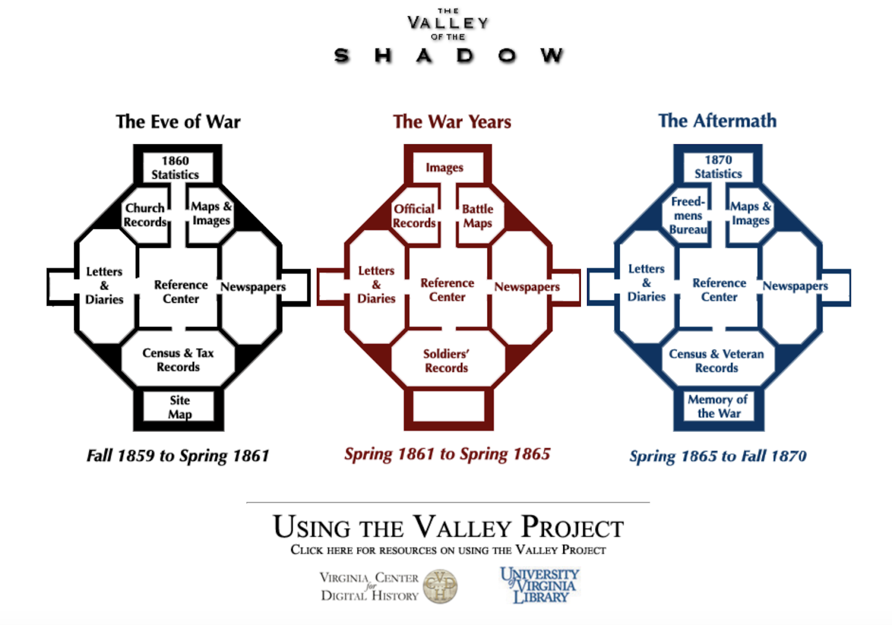

Figure 33. The Valley of the Shadow homepage

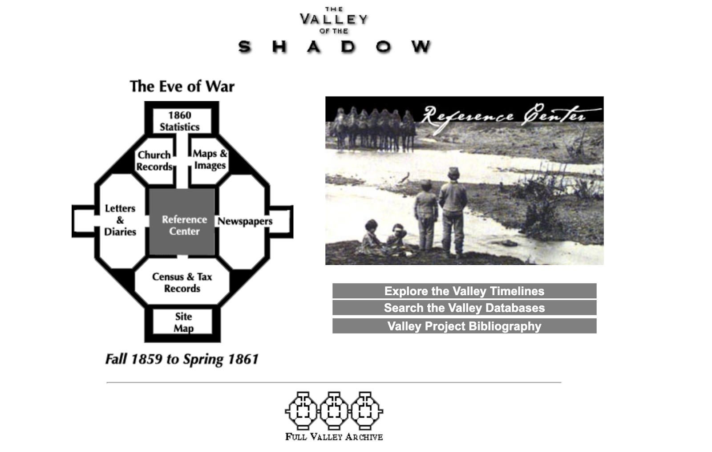

Figure 34. The Eve of War section, Reference Center page view

The project challenged the very format of historical monograph and the linearity of narrative itself, mostly using hypertext, rendering a "juxtaposition and connection of the unexpected" (Ayers 1999). In the late 1990's, hypertext was really in the hype among those trying out their first electronic ways of writing history. In 1998, David J. Stanley, reviewing the works of his namesake David J. Bolter, *Writing Space: The Computer, Hypertext and the History of Writing* and George Landow, *Hypertext: The Convergence of Contemporary Critical Theory and Technology* (1997) was perhaps one of the first to make a clear reference to the use of hypertext in “experiments in writing” – a Robert A. Rosenstones’s phrase – as a form of (capitalised) *Digital Historiography*:

The computer—specifically hypertext—makes such experimentation possible. Hypertext refers to the digital connection of words as in a web, not in a linear chain as in a printed text. Rather than being confined within the physical limits of the printed codex, the "text" of a hypertext expands to fill the electronic network, since any block of text can be theoretically linked to any other block of text somewhere in the electronic ether. The plot of the text meanders through this web, determined as much by the decisions of the reader as by the intentions of the author. Therefore, the computer screen provides a non-linear writing surface where there is no beginning, middle or end to the text, where traditional notions of linear plot and sequence are overturned, and where the solid boundaries between writer and reader are shattered. (Staley 1998)

The allure of hypertext, indeed, echoed in many other works (Chartier 1998; Darnton 1999; Andersen 1996; Landow 1997). However, Staley’s cautionary call to “first [before rushing in to experiments] explore the implications of such experimentation, in order to ask and answer *metaquestions* about digital narratives to determine if we truly wish to follow this path” (Staley 1998) was inviting us to an exercise of another sort of historical imagination; one about the representation itself and the impact of techniques and technologies on it, not solely on the represented thing, to which we are more accustomed. However, his warning did not seem to have had much effect, at least on the Anglo-Saxon tradition where the tool-driven and experimentation-driven rapidly evolved in a sort of common spirit of the epoch, again, permeated by a certain culture of project. Although partaking Staley’s concerns on the need to make these *metaquestions*, I would say that it is only truly possible if one puts their hands-on these new technologies to manipulate them, directly. Only through this first-hand experience, it is really possible to grasp their real potential and limitations. *Grasping*, in this case, can be read in the terms of Erns Cassirer. Known for his relational conception of sciences and his in-depth philosophical appraisal of culture as *praxis*, Cassirer claims that

“all intellectual mastery (*geistige Bewaltigung*) of reality is tied to this double act of "grasping" (*Fassens*): to "grasping" reality in linguistic-theoretical thinking and to "grasping" it through the medium of knowledge; to the conceptual as well as the technical design. (Cassirer 1995, 52)

In other words, this fundamental interaction, the twofold grasping, is a ‘hermeneutic act’ (Hall and Ellis 2019, 125). This *grasping* can, as demonstrated by *The Valley of The Shadow,* and as I myself experience through Memorecord, unleash historical imagination from traditional conventions on formats and performance in representation.

I believe the relative delay for digital humanities to enter into the (more) critical turn, as well as the discipline of history to start to reflect, deeply, in the metaquestionsproposed by Staley – not only suggesting that there are questions, but trying to *formulate* and *answer* them – is due to the belated realisation that *building* and *doing* are not solely a manual-technical work, but also an abstraction of a kind of historical imagination. The contact with the experimental apparatus, hence a fundamental interaction in the lines of what meant Cassirer, is essential to complete a thorough, critical process of interpretation. Without this holistic interpretation, that encompasses both intellect and senses, the metaquestions about works that are digitally done would risk being too generalising, while the possibility of reasoning through this grasping could be a way to seek objectivity, as a broader epistemological “organising concept” (Hacking 2004, 08). In other words, experimenting, even without knowing the answers to the metaquestions in advance, is a way to enhance both our historical imagination about the *represented thing* and the *representation*, and, finally, to support historians in their search for rigour amidst the (no longer so new, but ever changing) novelty of the digital component.

I am not advocating for any full objectivity since all judgments depend on subjective perspectives and worldviews. I am rather arguing for the historian's *tacit* and *intellectual* involvement when working along with the digital component in experimentation – hands-on setting – to be acknowledged as essential to the interpretation of *what* we create with the digital and *how* we do it. Based on my experience with the digital, especially through the fairly basic computing tasks I conducted with Memorecord (e.g. activating the web scraping robot or running and adjusting scripts for updating the harvest gallery on the website), I think that the powerful aspect of *graspings* is that it bridges our aprioristic expertise, based on traditional historical methods, and new experiences, helping us to make better sense of what we are doing while learning it ourselves – sometimes it may confirm our speculations, other times it may refute them, and yet might elicit new questions.

A simple example of it that I have already discussed was the frustration of my attempts to use PixStori as the main tool for Memorecord. Despite my will to expand the usage of PixStori in the crowdsourcing, I only learned how the limitations of the tool would interfere in the harvest when I tested it during the fieldwork. To put it another way, if you want to learn to ride a bicycle, you need to ride the bike, no second-hand/third-person account, manual reading or theoretical treaty will substitute the experience. And again, the other way around, expanding this simplistic example: if you (knowing how to ride) were to explain to a child *how to ride a bicycle* before her/his first try, you would then utilise your tacit knowledge (acquired by experience) to offer some hints, you could even demonstrate it or show some tutorials; yet, even after you have mobilised all your tacit knowledge to explain it to the kid, she/he would only truly learn it when she/he had practiced it by her/himself. By trying to explain it, you would become more aware of your skills and perhaps think about them for the first time, but, only other riders would grasp what you mean by the real feeling of balance and how to reach it. The moral? One must experiment, and adopt a self-reflexive posture, to be able to imagine and answer (good) metaquestions.

We can see a fine application of some good metaquestions in the original digital scholarship experiment that Ayers and Thomas published in 2003, a few years after launching *The Valley of the Shadow*. In a simplistic description we could say it was an electronic journal article, but *The Differences Slavery Made: A Close Analysis of Two American Communities* was way beyond it. It was published in the *American Historical Review* in a more traditional form (allowing downloads in PDF) but offered a complete electronic version in a separate online environment[30]. A few years ago, I analysed how William and Ayers were using the hypertext feature to narrate history online, collating evidence right together with the text, in a non-linear way (Lucchesi 2014, 134–36). In contrast with other big projects in digital humanities, like digital libraries or repositories, bringing the narrative dimension to the core of the experiment was something very prized to historians. Playing with the narrative structure and ways of reading the text, in a given suggested order (navigating points of analysis, for instance) or by elective sections of the readers' choice was not a mere transition of formats – from print to online/electronic. It was a practical example of how the digital as an *expressive medium*, to borrow Svensson’s sentence for a mode of engagement, could initiate and limit certain rhetorical styles. I argued we can see that they applied solutions, very probably based on metaquestions about the narrative structure, for instance, observing they added a *Reading Record tool*[31] to provide orientation to the readers that decided to follow the narrative in alternative ways. In such a manner, through this sort of Ariadne’s thread, readers could check which areas were not visited per section – *Analysis, Historiography and Evidence*.

# On serendipities

Following up this thread on hypertexts as the dominant forms of digital interference in the early days of digital history scholarship, I would like to propose to take a detour, and allow us to reflect a little longer on the hypertext feature. First of all, because it seems to be one of the more stabilised forms of digital interference that, despite technological development, has been a constant in digital objects, almost unaltered by the mutations of World Wide Web generations. Secondly, thanks to projects like *The Valley of the Shadow* and *The Differences Slavery Made* we can argue that hypertexts have significantly altered the scope for research’s presentation and serendipitous exploration. A general statement is that new serendipities may arise from the experimentation with digital methods. A more specific statement would be that forms of serendipities are intrinsic to the way we explore and discover things. Deriving from it, we can think about the digital component’s conditioning of the way we explore and discover things when doing or consuming digital history scholarship.

I think about ways of exploring contents and objects as well as writing, reading or consuming them otherwise as gestures that carry a disciplinary stamp, reflecting, perhaps, a certain *style*. Once more paying attention to the historicity of these gestures, we should consider which are the marks of history as a discipline in its more traditional fashion. As it has been brilliantly argued by Anthony Grafton, the footnotes embodied this disciplinary stamp in our discipline. Looking at the emergence of history as a discipline, Grafton concluded that in a historiographical text, the entity *footnote* could be considered an identity mark of the historical craft, because it:

It identifies both the primary evidence that guarantees the story's novelty in substance and the secondary works that do not undermine its novelty in form and thesis. By doing so, moreover, it identifies the work of history in question as to the creation of a professional. Like the whine of the dentist's drill, the low rumble of the footnote on the historian's page reassures: the tedium it inflicts, like the pain inflicted by the drill, is not random but directed, part of the cost that benefits of modern science and technology exact. (Grafton 1999, 05)

That is to say, footnotes grant professional, scholarly, authority to a piece of work. It is the evidence that indicates on the shoulders of which giants we are sitting. Moreover, footnotes have also been conditioning serendipity throughout the reading of texts and references, but, for printed texts, we can arguably say that serendipitous discoveries happen at a different speed than those in electronic formats, accompanied by links to sources and publications. The possibility of accessing references and evidence right away imprints different agility to reading and exploring a given publication. If footnotes are such a remarkable indicator of professional historians in the printed, traditional historiographic culture we are referring to through this thesis as a sort of establishment, what could be the specific marks of digital history? What stands for a digital historian like the whine of the dentist's drill stands to the dentists?

## Detours

Using hypertext with internal and external links, *The Differences Slavery Made* provided, both authors and readers with another way to explore the text. Through the Internet browser, in a sort of layered navigation, readers could follow the analysis argument and check the sources associated right away, almost immediately, without the use of footnotes. As I noted elsewhere (2012, 05), the possibility of bringing the evidence so (virtually) close to the text can be seen as a digitisation of what Hartog called *marque d’énonciation* (1992, 222), the *I see* and later the *I read*, that the French historian identified as founding features of the writing of history while reflecting upon Herodotus’ autopsy as a convincing procedure. I would add that the attention they paid to adapting (for lack of a better word) the narrative and reading experience from the print-like version to the electronic one by the implementation of the *Reading Record* tool could be a mark of self-reflection from which we can imply that Thomas III and Ayers did their homework, that the digital project has rigour, and that they not only cared for the part traditionally meant as research (the content, the analysis), but gave proof that they further extended their criticism to the technical elements.

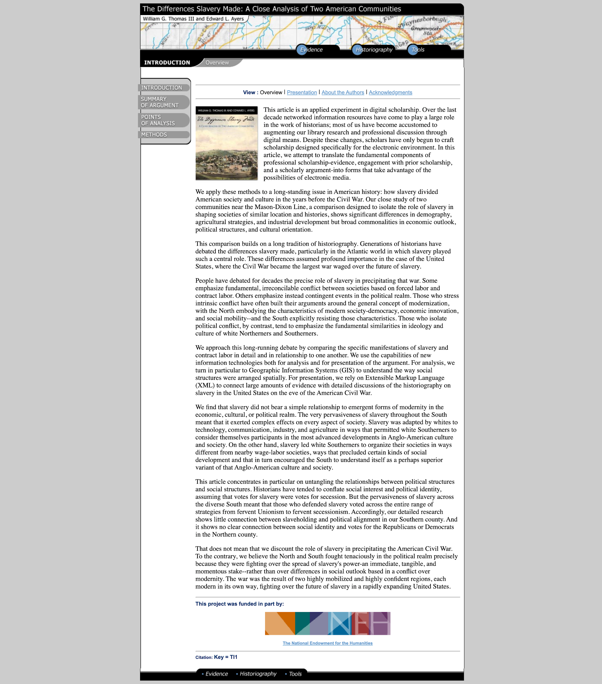

Figure 35. The Differences Slavery Made, Overview

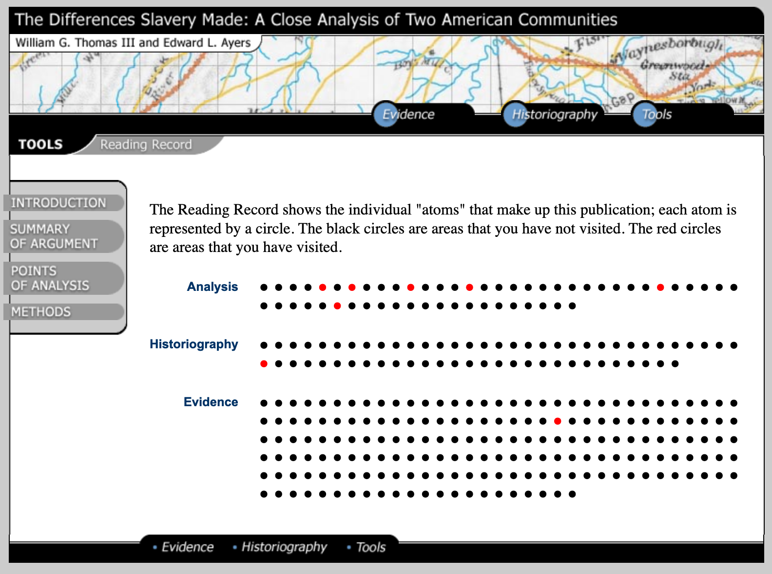

Figure 36. The Differences Slavery Made, Reading Record tool detail

The hypertext, hence, could be seen as one of the first elements brought by the digital component that plays a huge interference in the writing of history. By interference here, I mean it alters the piece of scholarship at stake in two major steps: *conceptualisation* (e.g. how do we structure the content, the publics we have in mind connections and cross-references that we can add to make an argument etc.) and *fabrication* (e.g. tools and techniques – hence, other skills – needed to compose the text and layout, to embed multimedia, to insert metadata and everything else to “execute” what was conceptualised). The interference thus is twofold; it challenges the *theoretical* and the *practical* framework of research.

However, years after the playful experiments with *The Valley of The Shadows* and *The Difference Slavery Made* (accompanied by many other groundbreaking digital initiatives), Ayers notes that little has changed in terms of what is acknowledged as scholarship, although researchers have been routinely using digital technology in their daily work (Ayers 2013). Considering more specifically the innovative exploitation of the Internet, Alan Gross and Joseph Harmon consider it "has been confined, for the most part, to side- stream venues; the mainstream publication has yet to be seriously affected" (2016, 86). In other words, digital scholarship and all the building it involves has not yet found its space in the mainstream.

## Accidental findings

Yet another manifestation of new ways that serendipities arises in digital scholarship are accidental findings. It is arguable that the new forms of narratives and presentation briefly discussed above might also come under the category of *detours*; in the sense that, prior to departure at the project's inception, the idea (the prototype) of the digital object was just an abstract plan, informed by theoretical assumptions that, in the end, turned out quite differently than what was conceived its conceptualisation. This was exactly the case with Memorecord as I extensively discuss in Chapter 2, but describing the many adjustments to the initial plan, in terms of methods and tools, was something I had to do along the way. The final outcome of Memorecord digital memory platform was unpredictable, but this unpredictability was not unwelcome since it was an experiment. By accidental findings, I mean surprising elements I did not expect to discover through this experiment. It is a subtle but important nuance here. The methodological detours and reshaping of the project design were, to a certain extent, desired, expected. While the accidental findings were more of a fortuitous event, if we like, a serendipitous discovery.

When I decided to do the Memorecord crowdsourcing through social media, I was aiming at collecting a variety of digital media content (e.g. text, video, photos, combinations of multimedia and so on). The main unit source, in this case, was a social media post on Facebook, or Instagram. I did harvest a variety of multimedia[32] through the crowdsourcing, what I was not anticipating was the extra layer of indirect participation added by the social media’s interactive nature. When parsing collected posts for moderation, one fundamental step adopted to notify participants about the successful receipt of their posts was to comment on their tagged posts (with #memorecord hashtag) with an acknowledgement to, at the same time, create direct contact with participants and to assure their consent for their post being shared publicly on Memorecord's social media channels and website.

What I was not expecting however, was to encounter something entirely organic on their timelines. In many cases, the comment section under the main post would display interesting conversations between the participants, author of the post, and one or more of their friends on Facebook, or followers on Instagram. Some stories encountered in this section, as I discuss in detail in Chapter 4, were of immense contextualisation value. An interference of this discovery exposed the fluidity of doing research on digital media and social media networks. While I was aware of the interferences posed by the unstable character of digital-born material, I always looked at this issue from the more technical point of view (e.g. issues of archiving and classification; preservation and maintenance of this material on the long term). The technical aspect, for sure, was a challenge, but as I described in the previous chapter, I managed to create a sort of pipeline – the crowdsourcing mechanism – taking its technical features into account. Yet, the crowdsourcing mechanism was faulty in dealing with the comment section’s accidental findings. Due to constraints of the privacy policies of Facebook and Instagram, web scraping the comment section is not feasible by legal means. This posed a huge dilemma for me, while I was thinking from a rather historicist point of view and wanted to be sure I could scrape and observe my digital born-digital sources.

What to do, before this crossroads? I first thought about manually printing all single comments. However, it would implicate yet another issue, one of profound ethical relevance when conducting historical research online[33]. I did not have the authorisation of the participant’s friends to watch and record their interaction. I could, although, access the post as many times as I wanted because, following Memorecord’s privacy policy, all posts needed to be public to become part of the collection. While I was following some of the comment sections they began growing, thus I organically started taking notes for each post in order to keep, at least, a record of my impression. As time passed, I realised that this solution was also very limited, since due to the very *raison d'être* of social media itself, posts were never truly closed, interaction keeps going and the conversation always remains open, unless the author of the post does not delete or change the post's privacy configuration

Before this dilemma, once again, the need for boundary work was reinforced. The solution I found, with some organising principles for objectivity, was to follow a few hints learned from the field of ethnography, but likewise to the historical interpretation, with its particular practices updated to the digital context. Similar to what we witness within the historical community of practice, ethnographic digital work is still facing a turbulent period of transition from the analogue to the digital age. Definitional debates echo the open questions of digital humanities, which is reflected on the various ways to label the emerging practices and authenticating sentences: *hypermedia ethnography* (Dicks et al. 2005, 26), *ethnography for the Internet* (Hine 2015, 19); *visual and sensory ethnography* (Pink 2014, 03), *ethnographic data analysis* (Boellstorf et al. 2012, 159) *or digital ethnography* (Hsu 2014)*.* Despite the specific emphasis of the different approaches, in the current state of play, many practices are overlapping and it is possible to identify a similar *topos* among the different ways to name ethnographic research by digital means. A similitude with digital history, most notably, is the (still) necessary reaffirmation of these practices as valuable research:

The increasing digital mediation in the field of ethnographic inquiry is undeniable. Through the engagement of individual users, governments, corporations, and even grassroots organisations, the ubiquity of computational technology has a far-reaching impact on social life. These technologies mediate culture by documenting, sharing, sensing, tagging, locating, trading, synchronising, filtering, automating, remixing, and mining the everyday experiences of our research associates. Rather than walking away from the digital, we ethnographers should give serious considerations to software as infrastructure and materiality at the sites of our research. We should also be mindful of our own digital research practices as we utilise digital technology to organise, manage, and publish our field findings. (Hsu 2014, 42)

In Chapter 4, I describe my composite of practices as a methodological kaleidoscope, exploring the strong need for flexibility that research on/about/through/within the digital requires in terms of boundary practices and research timing. Not the borrowing, but the true appropriation of practices from other disciplines are indispensable to conduct digital research and keep up with the constant updates inherent to the digital component. Further serendipities and accidental findings are enveloped in this *ballade* to the other fields of knowledge.

# The Digital Public History approach

If the role of historians and public historians, agreeing with Cauvin and Noiret, is the fundamental work of interpreting and contextualising individual and collective memories, what are the specific affordances that the digital, and hence, digital public history, may have? I will try to answer this question reflecting on the points of intersection between big public history as a plural field of practice, with its multiple modes of engagement and the digital history aptitude to embrace, appropriate and apply public history. While in the appraisal of digital history practices, the digital component was the core element, so is the public in the case of digital public history.

In the same way we need to bear in mind the historicity of digital history methods, it is important to consider what came before digital public history in terms of encounters between historians and the public. There are, in fact, constant shifts of performancesin “the history of historian’s role in the public space” (Cauvin 2016, 02). We can think about Herodotus and his representation of the others in his *Histories,* in Ancient Greece*,* passing through historicists in the wake of Leopold von Ranke, Charles Victor Langlois and Charles Seignobos and their introspection in the search for objectivity, and the later established professional historians who drifted away from non-specialised audiences as they plunged into a *style of reasoning* way too scholarly for the general public. Yet, beyond the highly scholarly spectrum, there have been several more popular historians, among which local historians and those employed by governments and institutions, that carried out relevant research in a local level or other scales also under the label of applied history [34].

Being public, thus, is not new for history, but the ways in which history becomespublic also varies in the course of history. Contemplating the ever-changing *public* facet of history means to look at its publics and audiences as a *destination* to public history, but also as places of departure and actors (i.e. people, communities, organisations), as a rich resource for both practice and reflection on practices. I like to think about the public as *topos* and *logos* for the reflection on the social function of history beyond the university walls; public as a malleable texture, a poetic matter and space for entanglements and disputes, encounters and diversity. As such, the public is ambivalent, home of conflicts and complex cultural manifestations where misuses of the past and battles of memories are in a constant scramble to dispossess the dispossessed and reassure the maintenance of the winners (Albuquerque Júnior 2019).

Beyond the most obvious goal of expanding the audience of history with the use of digital media, it is the concern with the public uses of history that brings together digital and public history. The digital seems to invite academic historians to interact more closely with popular culture, expanding the spaces of encounter (De Groot 2009). To think about the *popular* in history, let us remember Raphael Samuel's idea that history should not be considered as "historian's prerogative", but rather as a "social form of knowledge", a kind of work by many hands (Samuel 1996, 08). Ludmilla Jordanova points out that the past is essentially open, and narratives are public property (Jordanova 2006, 155). Identifying with the Brazilian accent of public history, that of epistemological pluralities, Ricardo Santhiago claims public history as an area of *study* and *action*. In his appreciation, he values the dimension of the *encounter* with the popular. This encounter, for Santhiago, happens in four intertwined fundamental forms of engagements:

the history made **for** the public (which prioritises the enlargement of audiences); the history made **with** the public (a collaborative history in which the idea of 'shared authority' is central); the history made **by** the public (which incorporates non-institutional forms of history and memory); and history **is** public (which would encompass the reflexivity and self-reflexivity of the field) (Santhiago 2016, 28, emphasis added by the author)

The digital is not central or indispensable to any of these specific engagements; public history has a life of its own, and the publics were there way before the digital. However, the digital component can act as a catalyst for the encounter between history and the popular. To Noiret, who advocates for the civic role of the junction of public history with the digital:

building a *digital public history* that is able to confront and critically mediate the incessant manifestation of private memories – and embalmed collective memories – is certainly a professional role destined to the work of the "public historian". (Noiret 2015, 40)

The historian's responsibility towards this civic attitude crosses all the modes of engagement. As professionals and public history historians, we should all be equipped to operate the critical mediation mentioned by Noiret. However, when it comes to curation and interpretation of data and digital heritage in a broader context, the digital component poses problems that go far beyond the problem of digital source criticism, or historical, scientific data criticism – *Geschichtswissenschaftliche Datenkritik* (Fickers 2020). The evolving state of play brings cross-sectional concerns for archival science, librarianship, museology, and information science (Ries and Palkó 2019). When it comes to working closely with these other fields, public historians long acquainted with the world of cultural institutions have resourceful baggage, however, the advent of the digital introduces new complexities.

A critical question here, thinking specifically on my experience with the Memorecord digital memory platform, is to consider the interplay of the public and digital competences of historians to deal with the emergence of new memory practices, such as the phenomenon of mediated memories. What could be a specific affordance of the digital to equip public historians to intervene in the mediation of memories in the public space? Does enabling the co-creation and emergence of other spontaneous bottom-up, non-institutionalised collections potentially serve this mediation? Could the creation of a digital public history project, in the lines of Memorecord, improve the conditions for this mediation?

My bet is that yes, bottom-up community projects open up possibilities for more dialogue and alternative pedagogies through which the public can be engaged in lesser passive ways. Yet when introducing the digital, we should be very mindful of the logic of the tools and environments we choose to avoid becoming victims of alienating logic that goes on the opposite way of the premises of a critical civic engagement. For instance, we can think about using the democratic power of the digital to challenge the logic of modern archival institutions and their power to include and exclude communities in the legitimated, embalmed collective memory of a given nation (Brown and Davis-Brown 1998, 20). This could be a very pragmatic contribution of digital public history projects in questioning the, often excluding, character of top-down collections done by institutions that, after all, store and create "imagined communities" (Anderson 1991). Or, to think out loud, would we be shifting from an imperial grammar of archives to another, that of the digital? I ask these questions with genuine doubts, not necessarily because I have the answers for them, but because as Ariella Aïsha Azoulay discusses, we need to break the silence about the unsaid forms of historical *erasure* For Azoulay, one way to challenge the *imperial temporality of archives* isunder the title of *potential history*, for which she urges a series of *rehearsals*[35] in a compelling exercise for unlearning of imperialism:

Much has been written on the colonisation of land—colonialism's signature enterprise, as the etymology of the word suggests (the Latin colonia means "settlement" or "farm"). Not enough, by contrast, has been written about another, complementary aspect of colonialism: the colonisation of time. The intertwinement of spatial and temporal conquest is responsible for the most durable forms of imperial violence in which citizens participate, often unbeknownst to them, through a plethora of mechanisms, sciences, idioms, assumptions, laws, norms, gestures, inclinations, aesthetics, affinities, and so on that became part of the exercise of imperial violence. Objects, especially those that came to be known as works of art, play a major role in rendering this double colonisation into a general condition that shapes citizens, making them complicit in perpetuating the dispossession of others with whom they are directly or indirectly governed—and to whom they should be indebted, since they have been, and continue to be, provided with plundered wealth that they consume as part of "their" culture." (Azoulay 2019, 139)

The fulfilment of this civic engagement, though, can also come in other fashions. For instance, by ensuring more generally accessible ways for our research to reach society, be it through the way we deliver our research results to the public, how we position ourselves as historians in the public debates, or how our knowledge can, albeit indirectly, intervene in the mediation of disputes about the past and contribute to societal problems. Any of these modes of engagement with the present could foster empathy, and this, in the sense of Robert Hassan, a mechanism for action in the world (2019, 03) that I believe, is the public role of historians.

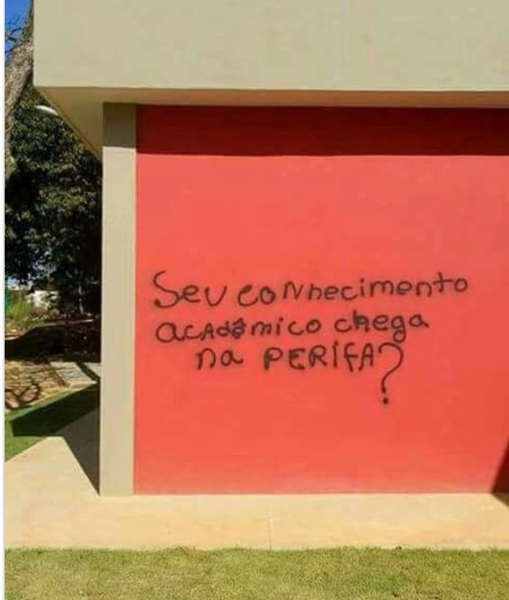

Figure 37. : Photo of a university wall in the South East of Brazil, “Does your academic knowledge get to the periphery?”, Unknown Author. Became viral in 2017.

Thinking along these lines, applying our knowledge to problems of the present, bouncing from practice to praxis, is not a passionate call for direct activism like the one by Azoulay, but the true work of historians. It is a recall for the social function of history and that the knowledge we produce should, somehow, engage with present problems that threaten our society and have roots in historical processes and events in long-disputed *memory battles* – e.g. racism and colonial, slavery inheritance; transitional justice and violent, authoritarian regimes (Pereira 2015).

Engaged research, however, does not necessarily require historians to hold on to slogans and occupy streets. It can also find its reason in the reflection about how we ask questions and how we conduct research to interpret and contextualise memories. Put in another way, methods are also modes of engagement with the present; the issue is whether we take a critical stance towards these practices or not. To give just one example, interrogating ourselves about why we select certain types of sources and why certain institutions have greater power in the selection and safeguard of documents. In Memorecord, when I chose to work with oral history and crowdsourced memories, one of the critical inflexions was the possibility of assessing the migrants' memories beyond what is customarily archived by the official memory institutions. The digital, in this case, enabled a different bottom-up approach. For the contextualisation of memories, however, the way we get access to them is far from trivial. In the following pages, I will discuss how grassroots or bottom-up approaches such as *history from below* (Thompson 1966) and similar examples can empower both historians and publics in the process of making sense of historical experiences anchored in questions from the present.

## A shared authority in practice

The public history core of Memorecord was built on the concept of *shared authority* (Frisch 1990). This concept, prized by oral history and public history practitioners, was developed by the oral historian Michael Frisch in the 1990’s. In a simple definition, shared authority informs us that experts in historical institutions and the public share the interpretation processes with non-hierarchical distinctions. It claims no special authority for historians, although, of course, we keep being members of a community of practice with rigorous methodological and theoretical rules to follow. In other words, acknowledging the existence of a shared authority does not mean a loss of value of the historian's craft, but should boost our capacity to embrace other subjects' savvy in their very own ways of telling their stories, passing them on, preserving and interpreting them. Moreover, shared-authority is a constant reminder that we, as professional interpreters, have to account for all the people’s historical agency, with no distinctions of social class, gender, race, sexual orientation or other artificial ways of social hierarchisation (e.g. intellectuals vs lay people). Most importantly, shared-authority does not treat non-professional historians engaged in public history projects or interviewed in oral history research as mere objects of study; participants, in this case, are rather *partners*, *co-authors* with a valuable say in the interpretation of the past. Shared authority underscores the ongoing negotiations over interpretations that oral historians, as narrators, shared with the interviewers. With open dialogues and iterative negotiations, oral historians and interview partners could discuss and seek compromises over disputed issues in a respectful, responsible way.

The idea of shared authority, though, is easier stated than practised. The limits of the concept, however, did not prevent it from becoming a reference for participatory and collaborative projects in recent years. It became a discussable model, for which historians needed to be in continue vigilante, but a reference of good practices within oral and public history relatable fields. Measuring the real achievement of truly respecting the principle of shared authority is subjective. However, watching for it can be an orienting rule for the mediation of the different agencies involved in a given project. Although its identification came from Frisch's experiences in the dual setting of an oral history interview, shared authority is also manifested in the relationship and mediation of engagements of collective organisations, cultural institutions, decision-makers and politicians involved in collaborative undertakings. Shared authority could, hence, be read as the ideal *temperature* of the trading zones which also arise in the context of public history initiative (e.g. between historians and museologists).

The premise for shared authority, however, lies in the initiation of a dialogue. The very grounding of shared authority is the interactions among historians and other partners in the public, cultural, legal or even private sectors, be it in citizen science projects, institutional memory initiatives, or other possible engagements, such as the development of public policies, management and preservation of cultural heritage, pedagogical activities, and so on. The range of contexts in which we can welcome a sharable authority heterodox way to, in Walter Benjamins's terms, "brush history against the grain" (Benjamin 1968, 257) is vast. However, concerning the modes of engagement of public history to mediate debates on memory – a debate which was core to Memorecord's conceptualisation – thinking seriously about how to better ensure a shared authority is key. Frisch's comment on the matter is pungent:

Memory is living history, the remembered past that exists in the present. In one sense, it is a force that can be tapped, unleashed, and mobilised through oral and public history to stand as an alternative to imposed orthodoxy and ofﬁcially sanctioned versions of historical reality; it is a route to a broadly distributed authority for making new sense of the past in the present. But in another way, memory is a deeply cultural artifact, manipulated in a host of direct and indirect ways, especially in an age of mass-mediation, to reproduce culturally appropriate attitudes and behaviors. It can thus stand as a prop of cultural power and authority, unless challenged in a variety of ways, of which aggressive historical inquiry and public presentation is certainly one. From this angle, it is history, not memory, that can provide the basis for shared reimagination of how the past connects to the present, and the possibilities this vantage suggests for the future. (Frisch 1990, xxiii)

## Revisiting History from Below

*History from below* may have started, to borrow Frisch's telling, as a way for "shared reimagination", a reimagination of histories that were long depopulated of ordinary folks. This, of course, was not because people did not live enough, but because history, looking at the big men and big nations, occupied in narrating heroic biographies, systematically kept them excluded. Sabyasachi Bhattacharya, in introducing the notion of *history from below* or people's history, as Samuel would phrase it, looks at Thompson's and his fellows' experience in the United Kingdom, but also elsewhere in the globe. He quotes an exciting manifesto of Puerto Rican historians that at the beginning of the 1970's expressed a feeling that many others around the global South would share, the outrage by the elitist profile of particular histories; the manifesto reads:

We face the problem that the history presented as ours is only part of our history... What of the history of the ‘historyless’, the anonymous people who, in their collective acts, their work, daily lives and fellowship have forged our society through centuries? (as quoted in Bhattacharya 1983, 03)

The idea of "historyless" people here is compelling to grasp the symbolic violence behind the process of stripping someone of their right to know their history and, ultimately, from their culture. History from below as an attempt to bring in people that served as a framework, greatly influenced by a Marxist orientation, to the emergence of social history in Britain, but also to the implementation of more democratic approaches to history, in the trail of practices emerging almost concomitantly such as oral and public history. Emmanuel Le Roy Ladurie adopted the perspective of people’s history to analyse a peasant community of the Pyrenee. The book that originated from this study, *Montaillou* (1979), was published for the first time in France and met a successful public reception, the same cannot be said about the critics of some of his erudite fellows (Sharpe 1992, 47). However, despite the criticism of his heterodox methods, the study shows the great appeal the perspective has among the, likewise, common people audience and indicated that some official historical sources could still be useful to explore these ordinary lives in the past despite the difficulty to access direct testimonies.

In our modern age, the penetration of the digital in everyday life is so deep that the problem of historians of today and tomorrow might not be exactly that of little data but that of an overwhelming amount of data, as discussed.. The challenge of the *Age of Abundance* (Graham, Milligan, and Weingart 2015; Rosenzweig 2003), thus, is about learning to truly make sense and interpret the copious records and traces of human activities our digital trail is leaving behind. In Memorecord's case, despite the existence of abundant digital material, I opted, nevertheless, for the co-creation of sources by means of social media crowdsourcing. While this type of method adds *noises* and *interferences* to the interpretation (i.e. *born-digital material* scaled-up to Big Data curation, interpretation and archiving), it also opens unprecedented opportunities for putting shared-authority in practice and, perhaps, revisits the *history from below* idea from yet another angle.

The digitisation of life and technological ubiquity is producing an unprecedented amount of historical data, but to approaches like the *history from below,* there is a fantastic assortment of digital egodocuments and other genres of records generated by each individual in the digital environment that opens the possibility for yet another closer perspective of the common life, rather zoomed in on the frugal details, perhaps way too close:

You do something, access a website of automobiles. You move from your home to a clothes' store, evaluate the seller and give your email and address. You think of someone and click on that person's profile at Facebook (with this you can notice that their posts will appear more often to you. You go to a coffee shop and have a cup of coffee while you use the Wi-Fi that is free to you if you make check-in in the cafeteria. You do a search about Denmark on the Internet. You did all these things, but you don't know why you did it. Meanwhile, everything has gone through recording systems that reveal a connection between everything you've done: the insertion into a data field, the crossing of information and the development of a psychological-market profile that is highly detailed will provide companies with an optimisation in the supply of services that are of your wish. So there's a trace of knowing why you've done all these things and what are other things you are more likely to do. But this information doesn't belong to you: you're ignorant about your wills, decisions, choices, and also what motivates them. Thus, Big Data decrees the end of free will. Big Data decrees the end of free will, of privacy, secrecy and autonomy. (Benevides 2017, 08)

The ethical implications of the above-described process are enormous, not only considering the unauthorised or improper use of one's data for commercial use but also concerning the risks of other types of abuse. Academia has not yet provided researchers with unanimous guidelines for research in these circumstances. Insofar, most of the lessons are coming to the field more specifically from experimentational investigations that do not have a set of shared protocols or best practices in place, but that explore the field by extending safety nets anchored in analogue practices while trying to grasp the best way to assess the digital material and how to better respect the integrity and the privacy of the subjects involved. The situation is no longer a lack of sources or the problem of source interpretation; it has scaled up to data critique.

I believe that the possibility of closer interactivity between historians and their public partners, in this scenario, could favour the emergence of another degree of *history from below*, but now, no longer assuming historians have to go down. Drawing on the notion of shared authority, we could, perhaps, propose an approach that is rather horizontal, from equal-to-equal, and use the digital tools to approximate, even more, historians from the public partners. We could try to subvert the invasive perverse logic of Big Data, and start to experiment on more constructive, civic forms of engaging with people by means of digital communication. We could set out to a historiography that is less detached from ordinary life. And we must try to do this in a conscious and very vigilant way in order not to become accomplices or hostages of the process of freedom and knowledge alienation interpreted by the technical mechanism that conditions our research practice.

## Towards a 360º history

Just as the overture to **hands-on and thinkering** attitude is central to the completion of a *thinking by doing* mode in digital history, which I have discussed under the rubric of **digital hermeneutics**, the true experience of **shared-authority** is necessary to enable a genuine exercise of what I am suggesting to be a historiography closer to ordinary life, one that, finally, could try not to hierarchise the subjects and their ways of life**.** My claim originates from the perception that terms such as *below* or *grass-rooted* or *bottom-up* still refers to people’s history as a somewhat inferiorised approach. Or, putting it in another way, while it is instrumental to employ the oppositions *top* and *bottom* when referring to research approaches, the very choice of words may be reifying the class struggle and the hierarchisation of society in a *what comes first* (top), *what comes last* (bottom) logic. History from below is, notwithstanding, the main inspiration here. However, I believe that it is opportune to reassess the way we label it, as the title we give to it may be less productive today than it was at the time when it was coined. Back then, history from below was as statement in itself; the method and the title criticised the absence of ordinary people from historiography, more, specifically, working class in the tradition heralded by the *History Workshop*. Today, I believe that historiography is well acquainted with the denounce made in that statement. The internationalisation of public history, actually, also helped to invigorate this debate by shedding light into other forms of popular history, such as community project, with which Memorecord is also identified. However, all these histories are legitimate history afterwards. By emphasising that we are taking a perspective from below, there is an implicit suggestion that we are somehow descending from our regular point of view to another level. But where would we be descending from? The historiographical canons? I am convinced that rethinking this labels might be productive vis a vis the communities authority.

I raise the idea of 360º history inspired by Memorecord’s experiment design. Engaging with community members not only to collect the data, but to involve them in the process of shaping the platform was an eye opening experience. Likewise, interacting with participants of the crowdsourcing on social media helped be to gain a different visibility. I feel unease, however, to define that the perspective I had along the way was really from below. Throughout the different phases of the project, in many circumstances, I found myself looking at the community from different angles, using different ways to reach and maintain an exchange with them. Moreover, not all the people I encountered had the same role in the project; some were more actively participating then others, and the quality of their participation was also diverse: some have granted me an interview; others helped in in the pilot test of the PixStori app; some gave feedback on the design and layout of the platform; other suggested me issues on the very concept of the crowdsourcing; and most of them joined the memory harvest on social media. Finally, it is important to mention that many of them took part in one or more activities, or were collaborated with in the project without having never assuming any expected task related to the design of the platform or the feeding of the crowdsourcing, some helped me by simply welcoming me into the community, opening doors, introducing me to a few people and networks. Fundamentally, I realised at the end of the project that the 360º scope of the experiment, aiming at (re)visiting all the research’s phase, was not only a practical decision of how conducting the experiment, but became a fruitful approach to engage more fairly with community partners in different circumstances. This helped me to gain a better understanding of their different capacities within the project. It also contributed to my perception of the participants’ heterogeneity and how interchangeably they their role could be along the way. The 360º history highlighted in the title of this section is less to offer a new title, but to suggest that we need a new frame of reference; as such, the 360º outlook seems pretty useful. Instead of closing the historian’s visibility in a single standpoint it reminds us of the possibility of moving ourselves around to look at things from a different angle. That is, at last, what all community projects may require.

This circularity approach, so to speak, is ignited by digital public history methods that enhance communication with the publics and audiences of history. By doing so, 360º history also seize the opportunity of this closer encounter to rekindle history’s very bond with societal struggles. While closer to the people from whom we are learning from, the empathetic effect of our practices should not only be a potential result of our work outwards the discipline, it should also sensitise historians about the real meaning of the engagement with the public. In the age of Big Data and scalable readings, this closer look should also rewire our senses with the importance of individual contexts and experience to reimagine the past, as Frisch proposes, in the fairer way possible. Being out in the field for this kind of practice, even if we should end up interacting with people mostly through digital media (like happened with me in Memorecord), should, additionally, help us to refine our analytical capacities in a manner to welcome more diversity in our historical record samples. Likewise, being closer to ordinary life could sharpen our sensibilities in a way that we can imagine less homogenised narratives, and, yet, offer a meaningful contribution to historiography. In addition, it could help us to devise, improve and readdress our practices of interpretation and contextualisation in the digital and public space. In short, a historiography that is closer to ordinary life is practising history in its most empathetic way. Finally, I am fond of the 360º approach for its complementarity with the metaphor of the roundabouts for digital public history which I develop next.

### *A roundabout for digital public history: empathetic triggers*

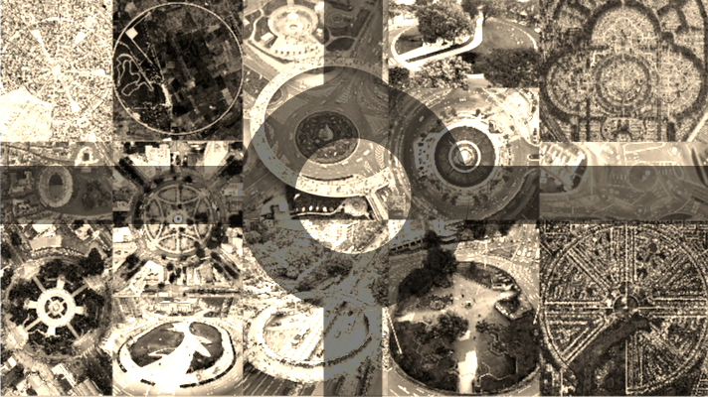

Figure 38. Illustration, Roundabouts. Photo collage of sixteen different types and designs of crossroads around the world. By Barbara Menezes.

Keeping with the metaphor of crossroads, I would like to propose another imagination exercise, now, proposing an encounter of what I discussed above as the *crucial contex*t for digital history to flourish with further paths that I believe can foster the empathetic approach of digital public history. Considering that in the perspective of a historiography closer to life we will need to apply digital methods to get in touch with our various publics and audiences, I would like to invite those prompts in the crossroads for digital history – *openness, collaboration, infrastructure, training & evaluation* – to join us in a potential roundabout for digital public history. I believe the metaphor of roundabouts is the perfect fitting for this sort of looking ahead exercise because roundabouts bring people together, in the same manner as the intersectionality of crossroads. But, in traffic, roundabouts were also designed as solutions to keep people going. It can, simultaneously, be a place of encounter, just as the crossroads, but invitintg people to move. Furthermore, around the world, we can find roundabouts of all flavours, with one or multiple lanes, slow or fast ones, with or without vegetations or monuments in the middles, and so on. When thinking about digital public history, we can imagine that historians will need to adapt their practices according to the local context and needs. While the shape and the surrounding landscapes may vary everywhere around the world, roundabouts are about accessibility, and it is possible to turn around the ring one more time if you need to reconsider your *exit*. Poetically speaking, if we let go of the stress of rush hours, roundabouts are also where things go round, it is a smoother intersection. Nevertheless, sometimes things can get a bit confusing when it is too crowded, but in compensation, in contrast with the simple crossroads, that sometimes obliges us to stop (e.g. traffic lights, works, accidents), roundabouts let everybody in. Hereunder, two further prompts that, instead of working as programmatic, should be read as flexible, open, empathetic triggers:

1. **Shared authority:**

As we saw above, the concept of shared authority could be read as the ideal *temperature* of the partnerships or trading zones that arise in the context of public history. However, shared authority is not an easy balance to meet. There are many challenges of authoritative discourses and the different languages spoken by the various partners. Finding a compromise on a certain interpretation proposal is not always an easy task when individual goals are too distinct or there are hidden agendas. Moreover, an important aspect of ensuring a shared-authority is the even distribution of roles and responsibilities with transparency. In many crowdsourcing projects, for instance, participants are not given the full account of the project, or, more problematically, it is offered to them with very little room for qualitative inputs in complex tasks. While there is no recipe for guaranteeing shared authority in place, a good solution, learning from the field of oral history, would be to establish a few protocols to orient the collaborative work or the participatory activities. Ongoing negotiations and periodic evaluation could be good thermometers. The most relevant is making sure that shared authority is not taken for granted and foresee, within the project structure, ways to check and ameliorate it in all the different phases of the project. Digital tools can help improve communication, as well as, if desired, give a few solutions to remote assessment.

1. **Participatory Design:**

Here, once again, it is important to think about how these different prompts are intertwined and should be iterative. Participatory design is the way, as I try to argue during Chapter 2, to engage participants in a meaningful way, in complex tasks that are fundamental to the development of a given project. If we want to ensure good maintenance of the shared authority temperature of our project, we should consider the implementation of participatory design as an infrastructuring aspect of digital public history projects. Participants can be involved in a massive variety of tasks along with a project development and may not become full-time partners, although it is necessary to guarantee that in a participatory design setting, participants are not simply offering inputs to basic tasks, but are really involved in activities that may shape or impact the project in its conceptualisation. Participatory design is, ultimately, great experimentation of shared authority.

# Back to Hermeneutics, but which one?

Despite due criticism, the late resonance of the arguments in favour of more self-reflexivity and greater engagement in cultural criticism had in the digital humanities could be explained as a side effect of the transition from analogue to digital. As I discussed in the introduction to this work, the speed of technological changes and the uncertainties about the development of computing, its new gadgets and the connection to the world wide web, may have corroborated so that at the dawn of the Digital Age there would be the greatest interest in the more practical dimensions of the changes at stake – formats, materials, tools, methods – while questions about the epistemological impact of these brand new facets of the artisanal work in the humanities would still be running in the backend. Experimentation, thus, gradually became the *ordre du jour* in the first years of digital humanities. The following trend was the establishment of laboratories and similar infrastructures to try out new research apparatus, manipulating the tools and materials in an environment where trial and errors would be recurrent, and failures could become more acceptable. Labelling these spaces under the umbrella of laboratories, mirroring the tradition of the hard science, not only lent them the right to innovate and eventually fail but was *tactical* in guaranteeing funding and employment for many researchers to sail through the crisis. In other words, looking retrospectively, before the plea for criticism could become a shared agenda for the digital humanities, the digital component became tactical for the humanities agenda.

While the previous waves of digital humanities have deeply explored the potential of the digital tools and methods, despite scattered criticism about the prevalence of *doing* over *thinking*, "building and making rather than theorising" (Spiro 2012, 28), it was only very recently that the critical deficit has reached more resonance among practitioners and is getting discussed more thoroughly, not only by the *theorisers* – who have been raising this flag for a while now – but also by the builders. There is, indeed, indications of a critical shift seen in the third wave of digital humanities, although, it is not seamlessly incorporating the dialectic dimensions of criticism, meaning the meta-criticism (i.e. self-reflexive exercise on using the digital) and the external criticism (i.e. cultural criticism, acknowledging that the digital technology and material are also cultural phenomena).

With respect to this latter point, some authors claim that taking on self-reflexive pedagogy, as in *building as a way of knowing*, could be an interesting exercise for bridging theory and practice in digitalwork*.* This proposition implies taking the instance that *building* is a form of scholarship (Ramsay and Rockwell 2012, 76) and that digital objects, as well as other forms of scholarly products, can embody arguments (Galey and Ruecker 2010, 412). An underlying argument for this assumption which I would like to bring forward here is the understanding that digital prototypes could do “rhetorically what a theoretical discourse does by presenting a thesis” (Ramsay and Rockwell 2012, 77). In this direction, in line with what Lev Manovich said during a Q&A session in the *DH 2007 Conference,* Alan Galey and Stan Ruecker (2010) suggest that “a prototype is a theory”. The authors claim that “the creation of an experimental digital prototype [can] be understood as conveying an argument about designing interfaces” (Galey and Ruecker 2010, 405) and propose to expand John Unsworth’s notion of scholarly primitives – *discovering, annotating, comparing* and so on – for including terms such as *designing* and *prototyping*.

The shift to this rather hybrid way of producing scholarship, as I argued in this chapter, could be an indication that a new style of reasoning about digital public history could be on the way. Within this style, the call for experimentation and the introduction of digital interferences are novelties to which historians are still not completely familiarised. To make sense of the unknown, I discussed the need to introduce a hermeneutic dimension within the practical and the theoretical work of digital historians that would take into account the ontological and epistemological implications of the digital in a pragmatic way: identifying and flagging interferences, and devising solutions to deal with them.

## Digital Hermeneutics as Hermeneutics of Practice

Finally, with the intention of providing a few directions to walk through the fog of the digital work realms, I depicted *crucial contexts* with short, open and flexible prompts which I retained the most suitable to ensure the best practices for digital history scholarship and digital public projects. In respect to digital history, I imagined crossroads bringing together openness, collaboration, infrastructuring and training and evaluation that could equip historians with the necessary skills to conduct digital history research and apply digital hermeneutics. For digital public history, I propose a roundabout that would combine the prompts of digital history with two further references for digital public history: shared-authority and participatory design.

In digital public history, the social function of history was made prominent and I emphasised the importance of participatory practices in the process of creating empathy. Uniting the digital history competences with the digital public history approach suggested the live practice of digital hermeneutics, underscoring the need for a continuous conjugation of theory and practice, interpretation and participatory projects, **hermeneutics and/as practice**. By systematically braiding theory and practice, and adopting a necessary self-reflexive stance toward everything we *do*, and we *think* when conducting digital hands-on work, we enable a new form of hermeneutics of practice. This specific hermeneutical approach may function as a visibility broker, assisting us in the process of unveiling the unspoken and implicit aspects of the research, facilitating the identification of the digital interferences we encounter throughout the research process. In this sense, the hermeneutics of practice should improve the researcher readiness to face the new research conditions placed by the digital component. Recovering Hacking's styles project, in an eventual stabilisation of digital history and digital public history as a new style of reasoning, a hermeneutics of practice should become a *sentence*of this particular style, supporting the search for historical objectivity.

1. Original passage in Italian: “Consegue che l’attività quotidiana – alta o bassa, eccezionale od ordinária – lascia tracce di tipo informático, que saranno i documenti e le fonti della storia futura del nostro presente. Como la Storiografia di una cultura alfabetica è diversa da quella di una cultura orale, così la Storiografia di una cultura digitale sarà – ed è già – diversa da quella di una alfabética.”
2. Through the methodological approach of *tertium comparationis (*the third part of comparison), borrowed from legal scholars, Serge Noiret and Thomas Cauvin argues that public history has a glocal dimension, because “public history is about applying universal methods locally. As a result, the local case study becomes comparable in its methods and practices.” (Noiret and Cauvin 2017, 26).
3. I believe Martí Peran’s evaluation of this is relevant to contextualise the current debates on the crisis of humanities as the *culture of projec*t and *culture of positivit*y that envelop life in an entrepreneurship rhetorics, plunged in references from the managerial world, with a productive motto that celebrates the "make thyself". This means that such cultures bring value and push a perspective of life as a project (e.g. setting goals, objectives, paths etc.) and the attitude of thinking and always acting positively (e.g. internalising the constant possibility of a *reset* to always start from new) (Benevides 2017, 05).
4. See: <http://media.obermann.uiowa.edu/archive/iowadigitalbridges/iowadigitalbridges.com/about/projects/greteman-lee-linked-reading/index.html>
5. See: <https://shakeosphere.lib.uiowa.edu/index.jsp>
6. See: <http://media.obermann.uiowa.edu/archive/iowadigitalbridges/iowadigitalbridges.com/index.html>
7. The current version of Perseus Digital Library is Perseus 4.0, available here <http://www.perseus.tufts.edu/hopper/>. Since April 2019 they have been working on a new reading environment – Scaife Viewer, available here: <https://scaife.perseus.org/>. The new viewer is a step toward Perseus 5.0, it is a specialised reading environment for pre-modern text collection in both their original languages and in translation.
8. The long quote is worth to illustrate these features: “In September of 1986 an “Exploratory Phase” of Perseus was funded by the Annenberg Foundation, during which Apple finally made commercially available a powerful Mac personal computer and the HyperCard software system needed for the hypermedia Perseus environment (Crane and Mylonas n.d., 18). Apple also contributed with $15,000 to the development of Perseus (19), and the interdisciplinary research team included a hypertext expert from Apple (Tim Oren) and two experts from Xerox PARC, Randy Trigg and Deborah Tatar; Tatar’s background in English literature is significant in terms of “the problems associated with a computing project in the humanities” (101). As the Editor- in- Chief of Perseus notes concerning the original direction and aim of the project: “Our initial goal was to assemble a critical mass of heterogeneous materials focused on a single, reasonably discrete subject – the classical Greek world” (Crane 1998, para. 2). However, this was soon augmented with Roman materials; a National Endowment for the Humanities grant facilitated a broadening of the scope of the library, and subsequently some of the visionary ideas that had led to Perseus began to be realised." (Lane 2016, 36)
9. See: <https://dictionary.cambridge.org/dictionary/english/interference>
10. Even when you are an expert in the field or object suffering the interference, you need to go through a bit of thinkering. It might be frustrating, sometimes – it was with me – not finding solutions right away, but for the creation of scientific knowledge, it is extremely important to try. Back in the early days of transatlantic radio, there was always a lot of static. Many sources of the problem were identified, but not always removed, electric storms were recurrent. In the 1930's, according to Hacking, "Karl Jansky at the Bell Telephone Laboratories had located a' hiss' coming from the centre of the Milky Way. Thus, there were sources of radio energy in space which contributed to the familiar static." Some years later, in 1965, radioastronomers Arno Penzias and R.W. Wilson decided to study the phenomenon with an adapted radiotelescope and the story that follows is one beautiful tale of accidental finding: "They expected to detect energy sources and that they did. But they were also very diligent. They found a small amount of energy which seemed to be everywhere in space, uniformly distributed. It would be as if everything in space, which was not an energy source were about 4°K. Since this did not make much sense, they did their best to discover instrumental errors. For example, they thought that some of this radiation might come from the pigeons that were nesting on their telescope, and they had a dreadful time trying to get rid of the pigeons. But after they had eliminated every possible source of noise, they were left with a uniform temperature of 3°K. They were loath to publish because a completely homogeneous background radiation did not make much sense. Fortunately, just as they had become certain of this meaningless phenomenon, a theoretical group, at Princeton, was circulating a preprint which suggested, in a qualitative way, that if the universe had originated in a Big Bang, there would be a uniform temperature throughout space, the residual temperature of the first explosion. Moreover this energy would be detected in the form of radio signals. The experimental work of Penzias and Wilson meshed beautifully with what would otherwise have been mere speculation. Penzias and Wilson had showed that the temperature of the universe is almost everywhere about three degrees above absolute zero; this is the residual energy of creation. It was the first truly compelling reason to believe in that Big Bang." (Hacking 1983, 159–60)
11. A fairly neglected aspect of the lack of criticism displayed in the digital practitioners' activities is pointed out by Domenico Fiormonte in their “more or less passive” attitude in their “engagement with the instruments they use” (2017, 17). The problem of such a passive stance is the apparent oblivion that technology is not neutral, as in the sense of Melvin Kranzberg (Kranzberg 1986). Fiormonte is surely correct to draw our attention to this fact following Alexander Galloway’s assertive: “technical is always political” (2006, 18). After all, the constant awareness around technology does not seem to be so straightforward. When working with and living around digital technology and tools everyday many of us seem to normalise it. I am far from disagreeing with Fiormente’s remarks, I instead see another issue looming in the background of these passive postures. I suspect that the passivity denounced by Fiormonte is very likely to be an unconscious response to the overwhelming stimuli of the digital, in which, I think it is plausible to say, there is a quasi-blasé attitude, mimetising the blasé outlook in the sense of Georg Simmel’s understanding, – a psychic phenomenon produced by modern metropolis, the “incapacity to react to new stimulations with the required amount of energy" (Simmel 1971, 329). Johanna Drucker offers another ingredient to it, the "persuasive and seductive rhetorical force of visualisation", she argues that it "performs such a powerful reification of information that graphics such as Google Maps are taken to be simply a presentation of ‘what is,’ as if all critical thought had been precipitously and completely jettisoned.” (2012, 86)
12. Fatalist previsions like the famous one by the French historian Emmanuel Le Roy Ladurie populate this deterministic imaginary: “The historian will be a programmer or he will be nothing” (1968), translated from his article on the *Le Nouvel Observateur,* see Figure 28. Other similar aphorisms, with milder degrees of determinism could be added to the list: “The historian who refuses to use a computer as being unnecessary, ignores vast areas of historical research and will not be taken serious anymore” (1990, quoted in (Boonstra, Breure, and Doorn 2006, 4); [A]n historian trained exclusively in qualitative methods, with no grounding in numbers, in computation, would also be "woefully deficient." And this scenario is not hypothetical. It is now a reality", Baker (2016, 21). I thank Max Kemman for keeping an updated list of them here: <https://www.maxkemman.nl/2017/10/historians-must-become-digital-now/>
13. As for the consideration of communities of practice within the history discipline, I value Kemman’s observation on the existence of “nested [communities of practice] COPs for subfields interested in different periods such as ancient, pre-modern, modern, contemporary history, or in different geographical areas such as French, German, or European history.” (Kemman 2015, 08–09). And for this reason, when I think about styles of reasoning, I also consider that each of these different communities of practice may also add their particular *accents* when speaking new styles.
14. Kemman builds upon the original idea of "brokers" developed by Etienne Wenger' brokers', to describe actors that within a trading zone "are able to introduce aspects of one community of practice into another, connecting the two communities and enabling coordination” (Kemman 2019, 193). Brokers bridge the communities of practice by "processes of translation, coordination, and alignment between perspectives" (Wenger 1998, 109). To explain *brokerage* in digital history, Kemman also draws upon a review of Wenger's concept that diverges two dimensions of brokerage, "bias, the extent to which the broker is closer to one community than the other. Here I found that leaders of digital history collaborations tended to come from history. The bias of brokers was thus towards history. The second dimension is cohesion, the extent to which one or both sides are cohesive groups or loose individuals. Cohesion is linked to group identity, so that [in trading zones] a cohesive community could be more likely to reject a broker as not part of their group” (Kemman 2019, 193).
15. See Chapter 1, *C²DH, a laboratory of historical uncertainty.*
16. Some elements of my crossroads overlap with Lisa Spiro’s proposed values for digital humanities – openness, collaboration, collegiality and connectedness and diversity (Spiro 2012) – my focus, however, is more concentrated in what could be the better context for favouring, specifically, digital history practices. In doing so, I base my speculations on my first-hand experience and on some critical literature I encountered in the past 12 years since I started to study the effects of digital technology in historiographical operation. My BA's monograph, written between 2008 and 2010, was exactly about it (Lucchesi 2015).
17. For a detailed discussion on the trading zones of digital history, digital history brokers and infrastructuring, see Kemman, 2019.
18. The task of developing these guidelines, however, is a demanding one, as the constant evolving character of digital technology continuously brings up new forms of digital representation and digital objects. On this matter, Rockwell dissects the *Guidelines for Evaluating Work with Digital Media in the Modern Languages*, by the MLA’s Committee on Information Technology focusing on the challenges of a specific guideline that reads “Review work in the medium in which it was produced” poses challenges for the evaluation of digital work very seldomly reviewed in formal review, such as tools (Rockwell 2011). Based on literature on interdisciplinary quality assessment, Julie Thompson Klein proposes a quite useful composite of indicators also adding factors for evaluation of interdisciplinary dimensions of digital scholarship and teaching (Klein 2014, 145–46). In 2015, the American Historical Association published their *Guidelines for the Professional Evaluation of Digital Scholarship by Historians* (AHA, 2015) developed by the Ad Hoc Committee on the Evaluation of Digital Scholarship by Historians. In this document, they propose a working definition of digital history as a “scholarship that is either produced using computational tools and methods or presented using digital technologies” and see the creation of digital platforms and tools as “as alternative modalities of scholarly production”, see:

    <https://www.historians.org/teaching-and-learning/digital-history-resources/evaluation-of-digital-scholarship-in-history/guidelines-for-the-professional-evaluation-of-digital-scholarship-by-historians>.
19. During the #dhnord2017 conference, organised by C²DH and [Maison européenne des sciences de l'homme et de la société](https://www.meshs.fr/page/accueil) held in Lille, from 27-29 November 2017, during the Q&A of the conclusive round table, the issue of training in digital history was raised, and one of the challenges on this front was identified under the dilemma of “training the trainers” in the lines of “we need to train the future generations of historians” to face the problems discussed in the conference and creating a critical mass that may also take part in the training of the yet to come generations (written note taken by myself). Speakers intervening at the roundtable: Andreas Fickers, Michael Frisch, Mareike König, James Mokhiber, Stéphane Lamassé, Serge Noiret, Sean Takats, Manfred Thaller, Gerben Zaagsma.
20. Original passage in French: “Mais les murs sont si hauts que, bien souvent, ils bouchent la vue”.
21. ‘Digital Humanities Luxembourg’ (DHLU 2012), organised by the *Centre Virtuel de la Connaissance sur l'Europe* (CVCE) and the University of Luxembourg in March 2012, as part of their joint research programme ‘DigitalHumanities Luxembourg: the future of research in humanities and social sciences’. To the programme, see: <https://www.cvce.eu/en/obj/the_digital_humanities_luxembourg_symposium_dhlu-en-4adc1f1d-13ba-47c8-bf84-f23c1f69c44d.html>
22. As in note taken by Pascal Föhr (2017, 09).
23. Comment of the artist: “This image was made in October 2011, just as Occupy Wall Street was flowering in NYC. It is based on the movement’s Declaration, written by consensus and agreed upon by the NYC General Assembly of OWS in the first weeks of the occupation. The inner circle is the list of grievances from that document, and the outer two rings of themes were decided on through a crowd-sourced editing process that took place in Zuccotti Park. Hundreds of people contributed to this image, and it was often distributed as an outreach tool for OWS, as an answer to questions like “But what is this movement about?” See: <https://justseeds.org/product/flowchart-of-the-declaration-of-the-occupation-of-nyc/>
24. Forthcoming volume, the author shared the manuscript with me. – Thanks for this too, Andreas.
25. Kemman discussed this issue in his analysis of inter-languages between trading zones, observing the need for a discursive proficiency to operate between different communities of practices. See (Kemman 2019, 196)
26. After "Arguing with Digital History Workshop" (September 15–16, 2017) the group sensitised the two-day discussion on a compelling white paper. In "Digital History & Argument" they propose a greater dialogue between historians and out digital history addressing the problematic arguments made through digital collections and digital public history have not been comprehensively incorporated into larger historiography conversations featured in, so-called, traditional scholarship formats, e.g. academic books and journals. They write: "On the one hand, it aims to demonstrate to the wider historical discipline how digital history is already making arguments in different forms than analogue scholarship.

    On the other hand, it aims to help digital historians weave the scholarship they produce into historiographical conversations in the discipline. The responsibility for integrating digital history with argumentation thus rests both with the digital historians who make implicit or explicit historical arguments and with the rest of the profession who must learn to recognise them." (Arguing with Digital History working group 2017)
27. This feeling has a pre-history, and the anecdote is worthy. In 2016, a few months after beginning my PhD research at the University of Luxembourg I gave a presentation about my research project in the International Conference “Luso-Luxemburguês - Recherches sur la migration portugaise au Luxembourg” (<https://wwwfr.uni.lu/research/fhse/dhum/research_areas/history/news_events/luso_luxemburgues_recherches_sur_la_migration_portugaise_au_luxembourg>), in which I happen to be one of the co-organisers together with my colleague Thierry Hinger from the Institute for History. In that very first presentation, I spoke about the methodology I wanted to apply in my project and highlighted open-ended aspects of working with the digital and the need of experimenting something new. It was a rather essayistic presentation compared to what other scholars were presenting. Overall, close colleagues seemed to like my presentation and made interesting comments during the social event, at the end. However, and this was striking, in an event dinner, I was directly confronted by another woman scholar who said (1st) that it was absurd that I was giving presentations in an international conference of that level before having finished my research; and that (2nd) what I had were mostly speculations and real scientific work is not based on speculation but with objectivity and facts; finally (3rd) the critics and my appetite at the dinner ended up with the remark on my PowerPoint having "too many pictures". That encounter led me to many thoughts on the line of *impostor syndrome*, especially because I was already feeling "not belonging" as I had recently arrived from Brazil, where academia has substantially different etiquettes. Along the way, when the tensions between what I *projected* and what was being shaped in the experiment became too high, due to frustrations on setbacks and insecurities about the lack of technical skills, that very conversation used to dance in the back of my mind. A colleague that was in the audience later told me that on the very occasion, during my presentation, she heard someone saying something in the lines that “this is not serious history”.
28. Usage statistics can always be problematic and big figures are often misleading. Nevertheless, even if we cannot be sure about the numbers, some figures about Zotero are evidence, at least, of the eminent interest the tool attracts. Sean Takats wrote about some figures, and the statistics issue, almost a decade ago. Back then, Zotero had about four million downloads, more than 620.000 accounts and, on the very day he wrote the text (21 May 2011), 275,000 instances of Zotero were run. See: <http://quintessenceofham.org/2011/05/21/on-usage-figures/>
29. The Valley Project details life in two American communities, one Northern and one Southern, from the time of John Brown's Raid through the era of Reconstruction. In the Valley’s digital archive, users can explore original letters and diaries, newspapers and speeches, census and church records, from Augusta County, Virginia, and Franklin County, Pennsylvania. Giving voice to hundreds of individual people, the Valley Project tells forgotten stories of life during the era of the Civil War. See:

    <https://valley.lib.virginia.edu/>
30. See: <http://www2.vcdh.virginia.edu/AHR/>
31. See: <http://www2.vcdh.virginia.edu/xslt/servlet/XSLTServlet?xml=/xml_docs/ahr/article.xml&xsl=/xml_docs/ahr/article.xsl&section=tools&area=record&piece=&list=&item=>
32. See Chapter 4 for analysis of the harvested material, section The Memorecord’s Cooking.
33. When my PhD research proposal obtained a favourable review by the Luxembourg Research Fund evaluation committee, it included a table of ethical issues that has to be fulfilled and one specific section of the application raising concerns on ethical issues and data protection since the very beginning of the project conceptualisation in 2015. Before being allowed to launch Memorecord, I also submitted an application to the University of Luxembourg Ethics Review Panel. In that application, I referred to two main ethics guidelines, the *Principles for Oral History and Best Practices for Oral History* (http://www.oralhistory.org/about/principles-and-practices/) and the *University of Luxembourg Policy on Ethics in Research*

    (http://wwwen.uni.lu/content/download/55603/657601/file/University%20of%20Luxembourg%20Policy%20on%20Ethics%20in%20Research_102012.pdf) and to other crowdsourcing projects that were references to me. Examples of other projects with similar privacy policies can be found on the American StoryCorps, which also collects people’s real stories, see: <https://storycorps.org/privacy-policy/>; and, in Europe, another well-known initiative that does similar crowdsourcing activities is Europeana (e.g. for instance, in the collections for Europeana 1914-1918 project, available here <http://www.europeana.eu/portal/en/collections/world-war-I>), which Terms and Uses regulating the data usage can be seen here: <http://www.europeana.eu/portal/en/rights.html>. However, in none of these documents was the dilemma with the social media comments section covered for a situation similar to Memorecord's.
34. For more on Herodotus and his work about “otherness”, see Hartog (2009); For the historicism turn and the birth of history as a discipline with objectivity, see Reill (1975) and Barros (2012); For the emergence of the scholarly tradition, see Grafton (1999); For the lesser scholarly and more popular kinds of historians, even before the emergence of public history as field, see Hilliard (2001) and Grele (1981); For a sense and context of applied history, see Conard (2002).
35. An example of these rehearsals could be seen at a recent exhibition curated by Azoulay, under the provocative title of *Errata.* In eight different projects, she makes an attempt to “intervene with the imperial grammar of photographic archives, to interfere in imperial knowledge printed in books, to unlearn imperial structures such as nation states, borders or status of “undocumented” imposed as fait accompli and to foreground the imperial origins of numerous gestures inherited by scholars, artists, photographers and curators, and used in their practices.” See: <https://fundaciotapies.org/en/exposicio/ariella-aisha-azoulay-errata/> Accessed May 29, 2020.